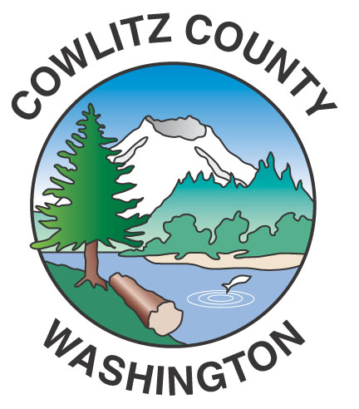

Department of Public Works
1600 – 13th Avenue South
Kelso, WA 98626
www.co.cowlitz.wa.us

Cowlitz County

Contact

Mark Koelsch

Public Works, Project Manager/Communications

Phone: (360) 577-3030

koelschm@co.cowlitz.wa.us

News Release

July 23, 2015

Road Delays for the week of July 27 – August 2, 2015

Kelso, WA - Drivers may encounter delays due to chip sealing operations on Monday, July 27 in the Toutle area and Tuesday through Thursday, July 28 – 30 and Monday, August 3 in the Longview area. Chip sealing is the primary surface type throughout Cowlitz County. Crews place a thin layer of oil, followed by specific rock chips. Sweepers ensure an even rock application while a roller packs the rocks into the oil. Within a week crews will return to sweep any excess rock that has not bonded to the oil surface. The treatment is applied approximately every seven years to keep roads in good quality. Chip seal is a cost-effective preservation treatment. Flaggers will direct traffic during chip sealing operations.

Roads scheduled for Chip Sealing include:

Monday, July 27: South Toutle Road (truck traffic may cause delays near the intersection with Spirit Lake Hwy)

Tuesday through Thursday, July 28 – 30: Cathlamet Road, Hunter Road, Shelly Road, Sara Road, Laughton Lane, Spruce Creek Road, Oak Point Road, Cedar Hills Road, Mill Creek Road, Whitewater Road, Robertson Road, Cameron Creek Road and Old Mill Creek Road.

Monday, August 3: Sunset Way, Sunset Drive, Sunset Lane, Sunset Place, Sunset View Road, 36th Avenue and 37th Avenue.

The Hazel Dell Road Reconstruction Project, from milepost 0.12 to milepost 1.15 (roughly the first mile north from the intersection with West Side Highway), is expected to continue into October. Drivers should expect delays of up to 20 minutes between the hours of 7:00 am and 6:00 pm in this work zone.

Paint striping operations will resume Friday, July 31 through Sunday, August 2. A list of the roads and areas impacted by the paint striping will be provided in an additional press release by the middle of next week.

Please use caution near construction zones and obey the directions of construction personnel and traffic control devices.

Paint striping, chip sealing, culvert replacements and road improvements are scheduled throughout the summer. For up-to-date information please call the Department of Public Works at (360) 577-3030, or visit our website at www.co.cowlitz.wa.us/publicworks, or the Cowlitz County Department of Public Works facebook page.

~End~

