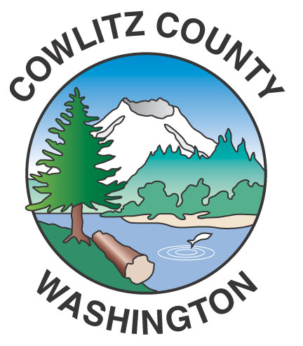

Department of Public Works
1600 – 13th Avenue South
Kelso, WA 98626
www.co.cowlitz.wa.us

Cowlitz County

Contact

Mark Koelsch

Public Works, Project Manager/Communications

Phone: (360) 577-3030

koelschm@co.cowlitz.wa.us

News Release

July 16, 2015

Road Delays for the week of July 20 - 26, 2015

Kelso, WA – Paint striping activities will break until the weekend of July 31 – August 2. Drivers may encounter delays due to chip sealing operations the week of July 20 – 24 in the Castle Rock and Toutle area. Chip sealing is the primary surface type throughout Cowlitz County. Crews place a thin layer of oil, followed by specific rock chips. Sweepers ensure an even rock application while a roller packs the rocks into the oil. Within a week crews will return to sweep any excess rock that has not bonded to the oil surface. The treatment is applied approximately every seven years to keep roads in good quality. Chip seal is a cost-effective preservation treatment.

Roads scheduled for Chip Sealing include: South Toutle Road, Gilmore Road, Frank Smith Road, Fiest Road, Wheeler Road, Lapham Road, Lull Road, Varner Road #1, Varner Road #2, Luebke Road, Crabill Road and Parker Road. Flaggers will direct traffic during chip sealing operations.

The Hazel Dell Road Reconstruction Project, from milepost 0.12 to milepost 1.15 (roughly the first mile north from the intersection with West Side Highway), is expected to continue into October. Drivers should expect delays of up to 20 minutes between the hours of 7:00 am and 6:00 pm in this work zone.

Please use caution near construction zones and obey the directions of construction personnel and traffic control devices.

Paint striping, chip sealing, culvert replacements and road improvements are scheduled throughout the summer. For up-to-date information please call the Department of Public Works at (360) 577-3030, or visit our website at www.co.cowlitz.wa.us/publicworks, or the Cowlitz County Department of Public Works facebook page.

~End~

