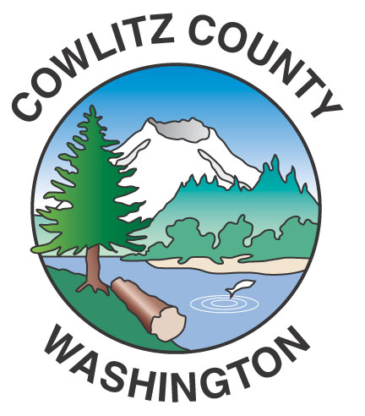

Department of Public Works
1600 – 13th Avenue South
Kelso, WA 98626
www.co.cowlitz.wa.us

Cowlitz County

Contact

Mark Koelsch

Public Works, Project Manager/Communications

Phone: (360) 577-3030

koelschm@co.cowlitz.wa.us

News Release

July 9, 2015

Road Delays for the week of July 13 - 19, 2015

Kelso, WA – Drivers may encounter slow moving paint striping trucks the week of July 13-19. Motorists encountering the lead buffer truck are asked to wait until the last truck has passed before entering the roadway. Drivers behind, or travelling opposite of the painting operation, should not cross the paint lines. If vehicles do need to exit the roadway, they should proceed slowly at a 90 degree angle. Paint drying times will depend on weather, but it is generally dry within five minutes.

Striping for Monday, July 13 - Kalama Area

Cloverdale Road

S. Cloverdale Road

Lane Road

Martins Bluff

Confer Road

Todd Road

Toteff Road

Vincent Road

Jaeger Road

Sauer Road

Old Pacific Hwy

Gore Road

China Garden Road

Rogers Road

Spencer Creek Road

Modrow Road

Striping for Tuesday & Wednesday, July 14 & 15 – Kelso Area

Old 99 South

Mt Pleasant Road

Kool Road

Fish Pond Road

Rose Valley Road

S. Goble Creek Road

N. Goble Creek Road

Zillig Road

Wagner Road

Alma Drive

Grim Road

Valley View Drive

Grade Street

Allen Street

P.G. Sweet Road

Harris Street Road

Miller Drive

Mt Brynion Road

Painter Roth Road

Williams-Finney Road

Johnson Lane

Pacific Avenue N.

Holcomb Road

Pleasant Hill Road

Washburn Road

Nob Lane

Striping for Thursday, Friday & Saturday, July 16, 17 & 18 – Castle Rock Area

Pleasant Hill Road

Bond Road

Powell Road

Dougherty Drive

Old Pacific Hwy N

Barnes Drive

Imboden Road

Burma Road

Toutle Park Road

Tower Road

Stillmeadows Lane

Toutle River Road

Riverview Drive

Si Town Road

S Silver Lake Road

Silver Lake Acres Road

Schutt Road

Dahlman Road

Elwood Road

Schaffran Road

Carnine Road

Estes Road

Kerr Road

George Taylor Road

Wiley Road

Hall Road

Streeter Road

Shenandoah Drive

Sightly Road

Moore Road

Kroll Road

Studebaker Road

Studebaker Spur #2

West Side Hwy

Agren Road

Chapman Road

Gassman Road

Beebe Road

E Beebe Road

Quick Road

Umiker Road

P H 10

Coyote Lane

Cline Road

Sandy Bend Road

Wren Loop Road

Hazel Dell Road

Striping for Sunday, July 19 – Longview Area

Woodside Drive

Coal Creek Road

Tanglewood Drive

Niemi Road

Harmony Drive

Eufaula Hgts Road

Shamrock Road

Ferncrest Road

Jackson Road

Grasseth-Poston Road

Stella Road

Fall Creek Road

Germany Creek Road

Willow Grove Road

Barlow Point Road

The paint striping schedule is dependent upon weather and equipment. The schedule may change at any time.

Drivers may encounter delays due to chip sealing operations next week on unpaved portions of Headquarters Road. Chip sealing is the primary surface type throughout Cowlitz County. Crews place a thin layer of oil, followed by specific rock chips. Sweepers ensure an even rock application while a roller packs the rocks into the oil. Within a week crews will return to sweep any excess rock that has not bonded to the oil surface. The treatment is applied approximately every seven years to keep roads in good quality. Chip seal is a cost-effective preservation treatment.

The Hazel Dell Road Reconstruction Project, from milepost 0.12 to milepost 1.15 (roughly the first mile north from the intersection with West Side Highway), is expected to continue into October. Drivers should expect delays of up to 20 minutes between the hours of 7:00 am and 6:00 pm in this work zone.

Please use caution near construction zones and obey the directions of construction personnel and traffic control devices.

Paint striping, chip sealing, culvert replacements and road improvements are scheduled throughout the summer. For up-to-date information please call the Department of Public Works at (360) 577-3030, or visit our website at www.co.cowlitz.wa.us/publicworks, or the Cowlitz County Department of Public Works facebook page.

~End~

