TO: Researchers of the Cowlitz County Road Engineer’s Records

FROM: Paul Galli, PLS
DRAFT

SUBJECT: Cowlitz County Survey Research

LAST UPDATED: August 27th, 2025

The purpose of this document is to detail the many different locations and types of survey related information available in Cowlitz County, especially those records related to the County Road Engineer’s Office (originally established in 1855 as “The County Surveyor’s Office”) which, for those of you who know, is a massive amount.

I understand that this is a large document that rambles and repeats things in places. My best advice is to start with “How to Research Cowlitz County Right of Way”, and then scan the headings in the table of contents and otherwise use a standard text search to look for what you need. If you see anything in this document that I have wrong, that you think I should explain better, or anything that is missing, please let me know. I would especially appreciate it if you could provide additional information that I don’t already have. Also, please note that this is a living document, and will be updated as we learn more.

Prior to 2020, the best way to find many of the records available in the Cowlitz County Road Engineer’s Office was to show up in person and do research onsite. That year, we created an online location for finding many of these documents (especially our road files, road plans, and survey field notes). If you stop by our office with a new zip drive (50 gig or larger) we can dump everything we currently have scanned onto it (which includes many of our filed/recorded surveys and private field notes, which aren’t currently available online).

Please note that some information cannot be scanned/copied, or has not been at this point, so not everything is available digitally, and may not ever be. Indexes for most hard copy collections are available online, and you can view these records in person during normal business hours (please call ahead). Some collections don’t have indexes yet. We have made our road files available on our website. We will try to get the rest of our surveys and other information on there as we can.

As you probably know, the Office of the County Road Engineer is an office of public record per RCW 36.80.015 and RCW 36.80.040, so the County Road Engineer is required by law to allow public access to its files at proper times. However, we will not do research for you and are not responsible for the thoroughness of your research, and cannot provide legal advice, though we do wish everyone to be successful and will help as much as possible by sharing our insight and knowledge of the available records. Hopefully, this document will help us towards that goal.
Table of Contents
Cowlitz County Surveyor/Engineer/Engineer in Charge/Road Engineer’s Office 4
Short History of the Office of the County Surveyor in WA State (currently called The County Road Engineer): 4
Historical Listing of Cowlitz County Surveyors/Engineers/Engineers in Charge/Road Engineers: 8
Timeline of Important Dates/Laws/Cases (with links): 11
How to Research Cowlitz County Right of Way 17
County Roadway Dedications “Waivers”: 19
Cowlitz County Public Works Field Notes: 19
Things to remember when digging through the Cowlitz County Public Works field books: 21
Plats and unrecorded plats in Public Works: 24
Unrecorded Surveys in Public Works research room: 24
Unrecorded Surveys in Map Cases (long square tubes): 25
Roadway Establishments: 25
Unrecorded Survey Maps from the 1970s, 1980s, and 1990s: 26
Andrew (Alvin) Bystrom private survey files: 26
Claud Davolt private survey files: 26
FM Lane private survey files: 27
Road Files: 27
Road Name Changes: 27
Road Index Books/Maps: 29
Road Logs: 30
Bridge Logs/Files/Inspection Reports: 31
Road Books: 31
Roadway Maps/Plans: 31
Roadway Vacations: 32
Volcano Roads: 32
1980s – 1997 survey maps: 32
Segregated Construction Field Books: 33
Professional Land Surveyor Surveys (1998 to 2011): 33
Current PLS Surveys: 34
Legacy Vertical Control: 35
Aerials: 35
Diking District Records: 36
Other Cowlitz County Departments 37
Cowlitz County Auditor’s Office: 37
Auditor’s Road Record (aka Auditor’s Road Book) 37
Assessor’s Property Index Books (Tract Books) 37
Assessor’s Abbreviated Deed and Superior Court Case Books 38
City Ordinances 38
Establishments, Waivers, Surveyors Reports, etc 38
Grantor/Grantee Deed Index Books 38
Plats 39
Records of Survey 39
Cowlitz County Commissioner’s Journals: 39
Cowlitz County GIS: 40
Cowlitz County Historical Museum: 40
Cowlitz County Superior Court Orders (SCO): 40
Other Sources of County Research 41
CDID#1 Headquarters: 41
City of Woodland: 41
Corps of Engineers: 41
DNR PLSO: 41
Longview Library: 42
Longbell Monuments: 42
Port of Woodland: 43
Washington State Archives: 43
Local Land Surveyors and their pre-1973 records: 44
Other Agencies and Organizations with Pre-1973 Records (or post 1973 responsibility to file records in the Office of the County Engineer) 50
Bonneville Power Administration: 50
Department of Natural Resources: 50
Washington State Department of Transportation (WSDOT): 50
Timber Company Records: 52
Georgia Pacific: 52
Longview Fiber: 52
Ryderwood Tree Farm: 52
Weyerhaeuser: 52
Public Works Online Research Resources: 53
GIS Map for Public Works Right-of-Way Documents: 54
Laserfiche Database (Road Files): 57
Research Indexes and Helpful Documents on the PW Website: 59

Cowlitz County Surveyor/Engineer/Engineer in Charge/Road Engineer’s Office

Short History of the Office of the County Surveyor in WA State (currently called The County Road Engineer):

One of the first projects that I was asked to complete when I started consulting for Cowlitz County in June 2012 was to figure out where the surveys of the Cowlitz County Road Engineer’s Office (CRE) were located. Their surveyor had left a year prior to my contract, and no one remaining knew where the survey documents were located. Being a mostly Oregon surveyor by experience at that point, I didn’t know much about the County Road Engineer’s Office in WA, so I started by researching its history, as I hoped that knowing more about that would help me locate the documents. In doing so, I realized that the key is that it was both the CRE’s and the County Surveyor’s Office (similar to Oregon, only here one office sufficed for two professions) and the survey duties required by law were to be completed by a “competent surveyor” (now licensed PLS). In this county, the Office of County Road Engineer also functioned as the County Surveyor’s Office until the late 1970s, under the direction of “competent” (after 1947, licensed) Land Surveyors, which is why so many private and non-road related survey documents are here.

In 1855, territorial law created the Office of the County Surveyor, whose main duties were locating rights of way, properties, and designing roads and bridges in the County for the County Commissioners and the general public (basically, anyone who asked and paid him). In 1895 these duties were clarified further to include mandatory and voluntary survey recording and review responsibilities (in addition to the retention of his field notes which was already a requirement), as well as other survey and engineering functions. In 1907, when the title of the office was changed to “County Engineer”, the core duties didn’t change (still surveying and engineering), and the County Engineer was required to be a …“competent civil engineer and surveyor”. In 1926, the Office of County Engineer was abolished in all but class A & 1 counties, and the duties of the Office in these counties were put under the County Commissioners, though the office remained in this County (they called him “Engineer in Charge”). In 1936, The Office was again renamed to “County Road Engineer” and it became an appointed position (in all Counties) under the direction of the County Commissioners. The requirement of the office was to be a licensed PE which (under the 1935 licensing law) also qualified him as a competent Land Surveyor on his own projects and allowed him to perform surveying and engineering duties on County Roads (as he always had). In 1947, the licensing laws were rewritten and the Engineer’s ability to survey their own projects dropped off, requiring the CRE either get their PLS or hire one. What really pulled together all of my research and made it make sense to me was the book series: “Inventory of the County Archives of Washington” by the Work Projects Administration, which contains a history of the office as they understood it at the time, written by (or at least with the direct consultation of) the people who were doing the work at the time (CREs). A digital copy of Cowlitz’s is available on our website. Lewis County’s description of the office, from the same book series, “No. 21 – Lewis County”, published April 1940, is included at the end of this discussion.

In 1946, all Civil Engineers (including all CREs) were competent surveyors (at least on their own projects) under the laws in place at the time. Presumably, all County Road Engineers were performing or overseeing surveys on their road and county property projects (ours certainly was). Our County Road Engineer at the time obtained his surveying license, presumably so that he could continue surveying and overseeing survey work done on County Roads and County Projects, as the County Surveyor/Engineer/ Engineer in Charge always had. He even continued as de facto “County Surveyor” after he retired in 1954 (according to conversations with surveyors who were around at the time), which may be why the next CRE wasn’t a PLS. Eventually, the “new” County Road Engineers were able to be Engineers only. I assume that this happened at different times in various counties, due to retirements of the older PLS/PEs, and that the surveying duties became delegated to a PLS in the offices (in many, if not most counties). Some of the state laws still contain language about the County Engineer doing survey work, though again, the research clearly shows that these are just remnants from when the pre-1947 Office of County Engineer (now CRE) was held by a competent Land Surveyor. I suppose they still can perform Land Surveying if they are dual licensed, though it seems like a lot to take on both in all but the smallest Counties. See RCWs 36.32.370 and 36.32.380 for the law requiring that the County Commissioner’s employ a PLS for survey work (similar to their responsibility to appoint a County Road Engineer for Engineering work), and the requirement to record these surveys in a “record book”.

Shortly after the 1947 licensing act, and the major changes in the Engineering/Surveying licensing laws, the department of surveys and maps (today’s DNR PLSO) was added to state law (1951), then was funded and the first head of the department started in 1956 (Burton Ingalls). Soon after that (1959) is when the last survey was officially requested by a local surveyor to be recorded in this office (under the old 1895 law – at least that I have documentation for). It appears that they continued to take and index private surveys here at Cowlitz County, in addition to surveys by public agencies which were required to be filed here by state law after 1973 – if not recorded with the auditor, up to the present day.

Finally, in 1963 (as best I can tell from RCW), the old Remington Revised Statutes (including the 1895 County Surveyor recording responsibilities) were scrubbed from state law, modified, and placed in the County Commissioners’ “new” RCW. Until then however, the Office of County Surveyor/Engineer/ Engineer in Charge/Road Engineer was the only place in this state that one could actually “Record” a survey map if they chose to, assuming they submitted to a review and payment of the recording fees.

With this knowledge, now I knew why so many surveys were in this office. The CRE’s Office has always been a survey recording office for any kind of survey (private, public agency, County Road, etc.).

One question that I still have (of many) is whether or not the County Road Engineers thought they would be giving their historic survey documents and responsibilities regarding private surveys and surveyors to licensed land surveyors in 1951 when they backed the “new” Bureau of Surveys and Maps. There had just been an Attorney General’s Opinion regarding recording (in The County Road Engineer’s Office) only surveys by competent (meaning licensed) land surveyors, so maybe that exposed some things that they wanted changed? Maybe not every County had a PLS on staff in 1951 or not every CRE wanted to bother with, or felt comfortable with reviewing and recording surveys, as they were required to do? I still need to look at the WSACE minutes from that time, when/if I get a chance (maybe the answer is there?).

I would also appreciate it if someone could tell me why Washington changed the name from County Surveyor to County Engineer in 1907. I’ve been wondering (I have no real proof for this other than circumstantial) if it was in response to the Benson Syndicate and the Oregon Land Frauds. The trials had been going on for years at that point, and Steven Puter’s Book: “Looters of the Public Domain” was published the next year. I’m sure that the County Surveyors in Washington at the time didn’t like the association one bit, and probably wanted to distance themselves from that mess. BLM surveyors became “US Transit Men” for the same reason (or so I’ve been told). Makes me wonder…

See “Timeline of Important Dates/Laws/Cases (with links)” (below) for backup on how I came to these thoughts. There are links to the prior laws, that 1950 AGO, references to the 1940’s “Inventory of the County Archives of Washington”, and other things. If you disagree with me, or have additional information to add to the discussion, please let me know. Protecting the property records and monuments of the public and private owners of this state is of the utmost necessity, and the more we know about them: who created/set them, the laws/reasons they were created in the first place, and where they are now, the better we can locate and keep them for future generations. These documents/monuments were created/set with the good faith understanding that they’d be available to protect property rights of future generations. It’s up to County Road Engineers and PLSs to work together to make sure that continues.
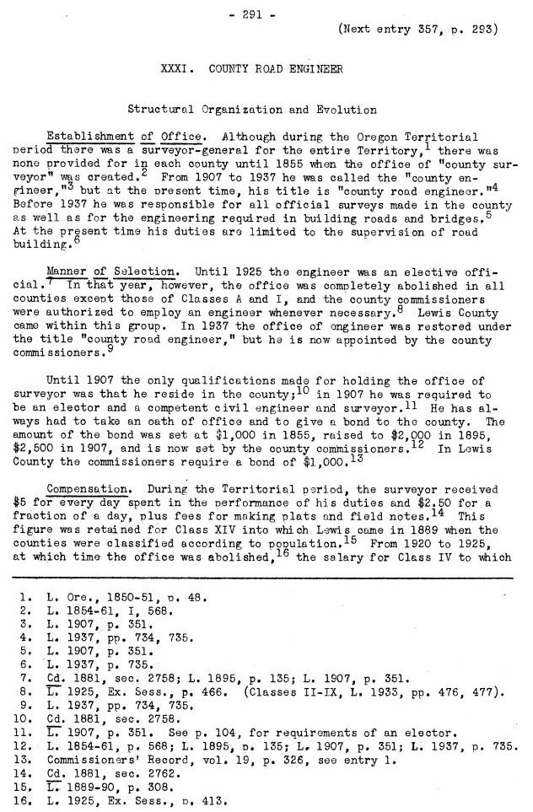
Excerpted from the “Inventory of the County Archives of Washington No. 21. Lewis County (Chehalis)” dated April 1940 by The Washington Historical Records Survey Project, funded by the Work Projects Administration and created in the Spokane Office.
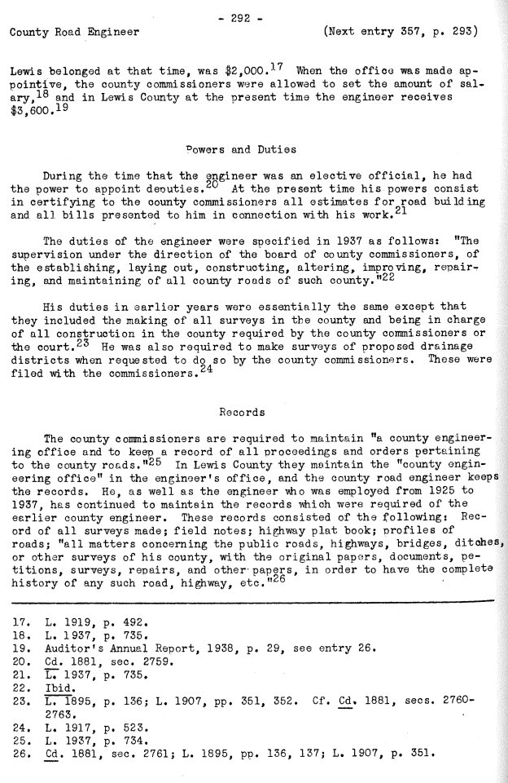

Historical Listing of Cowlitz County Surveyors/Engineers/Engineers in Charge/Road Engineers:

Previous County Surveyors and Engineers Responsible for Surveys (County Road Engineers who did their own surveying). This can help date undated records. See also list of County Engineer and Surveyor employment dates by Al Hannaford, dated June 18, 1980 (on the server), which gives some document references. I’ve pulled together bios and other historical data on these people, as available from others. It is here on the Public Works Server: F:\General Survey\Survey Research and Indexes\History of Roads in Cowlitz County\Cowlitz Eng Employees

Name | Year | Year | Title | WA PLS#
Peter W Crawford – | 1860? | 1882? | County Surveyor
L S Caudle – | 1882 | 1883 | County Surveyor
Samuel G Caudle (Candle) – | 1882 |  | Contract Road Surveyor
Benjamin A Deetz | 1883/11 | ???? | County Surveyor
Benjamin Franklin Jenkins – | 1883 | 1884 | County Surveyor
Benjamin F Ivie – | 1884 | 1889 | County Surveyor
Benjamin A Deetz | 1889 | 1892 | County Surveyor
William Mayer | 1891 | 1892 | County Surveyor
Fred Milton Lane | 1893 | 1896 | County Surveyor
Andrew (Alvin) Bystrom | 1897 | 1900 | County Surveyor
William Mayer | 1901 | 1901/07 | County Surveyor
Fred Milton Lane | 1901/07 | 1906 | County Surveyor
Clyde Raymond Bell | 1907 | 1908 | County Engineer
G B Roberts | 1909 | 1912 | County Engineer
Robert Charles Westwick  Frederick Charles Cramer | 1913  1917 | 1916  1920 | County Engineer  County Engineer | 317
Ernest A Middlebrooks | 1921 | 1926 | County Engineer | 206
Frederick Charles Cramer | 1927 | 1936 | Engineer in Charge* | 317
Frederick Charles Cramer | 1937 | 1945/01 | County Road Engineer | 317
Claud Olson Davolt | 1945/01 | 1954/01 | County Road Engineer | 328
Harry D. Martin | 1954/01 | 1963/04 | County Road Engineer*** | No PLS
Claud Olson Davolt | 1963/05 | 1963/07 | Interim County Road Engineer | 328
Lawrence E. Riedesel | 1963/07 | 1972/12 | County Road Engineer | 8636
Donald G. Berdan | 1972/12 | 1978/04 | County Road Engineer | 6388 & 7137
Nelson Graham | 1978/04 | 1983/02 | County Road Engineer | No PLS
Ken Stone | 1983/02 | 2003/02 | County Road Engineer** | No PLS
Donald (Don) Lee Day | 1997/07 | 2011/11 | PLS | 34667
Paul Galli | 2012/06 | 2014/12 | PLS Consultant | 41079
Paul Galli | 2015/01 | Present | PLS | 41079
*From about 1927 to 1937, the County Commissioner Chair was Ex-officio County Engineer, due to a 1926 law that eliminated the elected County Engineer in all but Class 1 and A counties, until 1937, when it became appointed. As far as I can tell, the office functioned essentially the same as it did before the change, and they kept all the same documents as before.
** From about 1997, Ken was both the County Engineer and Public Works Director, and his assistant engineer (who actually did most of the County Engineer work) didn’t do his own surveying, so they hired Don Day to do it.
*** As best I can tell, from information provided to me by George Raper, Arden Stocks, Larry Keatley, and others who were around at the time, or knew him, Claud Davolt continued acting as County Surveyor from his retirement in 1954, until 1963, when a new PE/PLS (Riedesel) was hired to replace Martin. I found no evidence of this being an “official” position.

Others Associated with The County Surveyors Office:
Arne L. Loren
A.R. Cruikshank – 19?? – 19?? – Deputy County Engineer
Claud Olson Davolt – 1925-1926 – Deputy County Engineer
Claud Olson Davolt – 1927-1944 – Assistant County Engineer
Dan Griffith – Made Rearchain – 12/28/1973 / Made Head Chain – 3/22/1974
E.A. Middlebrooks – Diking Engineer, business with Jackson
F.C. Cramer – 19?? – 19?? – Deputy County Engineer
F.C. Cramer – 19?? – 19?? – Assistant County Engineer
Gary Gonser
George Bradford – 1995-2002? – GIS Land Surveyor
George Jacob Poysky – 1915 – 1920 – Diking Engineer for most (all?) of the early dikes – had
an office in Kelso State Bank Bldg. / it appears he had his surveying done by others
(Lane, Jackson, etc.).
G.K. McKenzie – Worked in the County Engineer’s Office as Deputy County Surveyor from
about 1912-1923 (per Jerry and Hannaford) See surveyor’s record survey 132 – 1913. Was Kalama City Engineer sometime in the 1920s. We received some of McKenzie’s records from Arden Stocks.
Harry Becker – Crew – 19?? – 19?? – Worked for Claud Davolt for many years. Had a
business with Larry Keatley for awhile (back in the 1970s?).
James Talley
John Erion – 1/15/1974 – Made Construction Inspector /
Larry Higgins
Larry Keatley – Crew – 1966-197? And 3/30/1973-20??, licensed later and ran his own
business around town. Worked with Harry Becker and Claud Davolt.
Pat McGeary – Named Headchain – 08/14/1973 – Left – 12/28/1973
Roy Mohr – Assistant County Engineer – 1949 (see CCCJ V21 Pg 610)
Tom Morgan – 19??-1994 – GIS Land Surveyor
Tom Schultz – Rear Chain from 6/4/1974 to 7/30/1974
U.G. Jackson – 191?-1924 – City of Kelso Engineer. Business with Middlebrooks – 1924 - ?? –
Diking engineer for several districts – Worked for USACE in Portland sometime from
late 1930s to mid-1950s and worked up here that entire time – seems to have done a
number of retracement surveys in the area – are his files at the Corps? - 462
W. Muncaster

Notable Equipment:
K&E Transit from Shannon and Company – January 8th, 1974

FYI – The highlighting and question marks in this document typically indicate that I still have unanswered questions about many things and research left to do. Most of my research is typically done during a project, where it is relevant to something the County is building or reconstructing. As soon as I figure out what I need for that project (IE: find a County Surveyor’s dates of service so I can approximately date signed but undated records), I move on to something else. Part of this document is a reminder to myself of what I’ve already found, in order to remember what I still don’t know, so I have something to build on for future projects, or when an answer to one of my many questions presents itself (as it sometimes randomly does) and so I won’t have to redo past research when I forget something.

Jerry Olson’s website http://www.northwestglosurveyors.com and numerous chats with Ken Stone (Cowlitz County), Howard Richardson (Olson Engineering), Larry Higgins (Cowlitz County), Ken Paul (Clark County Surveyor), Karl Germunson (Germunson Surveying), Rich Williams (Gibbs and Olson), Bill Mumma (WSDOT), Kris Horton & Pat Beehler (DNR PLSO), Andy Blatchly (Weyerhaeuser), Bill Watson (Cowlitz County Museum), and many, many others have been hugely helpful in pulling together this information. Without the community’s research, experience, and insights, I wouldn’t have been able to share any of this information, as the type of information they have put together and have given out freely is just not possible to do on day-to-day projects, in something less than about 200 years. Thank you!

Timeline of Important Dates/Laws/Cases (with links):

Highlighted dates on the next 4 pages are intended to visually group research topics together: #### - Right of Way, #### - Office of the County Surveyor, #### - 5 yr unopened vacation law, #### - Licensing Laws, #### - Secondary source history, #### - Survey Recording/Filing

1854 – “all county roads shall be sixty feet in width, unless the commissioners shall, upon the prayer of
the petitioners for the same, determine on a less number of feet in point of width.” https://leg.wa.gov/CodeReviser/documents/sessionlaw/1854pam1.pdf (PG 344, Section 13)

1855 – Elected Office of County Surveyor is created in WA state law. The County Surveyor was required to keep field notes and then give those notes to his successor.
https://leg.wa.gov/CodeReviser/documents/sessionlaw/1855pam1.pdf (Page 25).

1866 – RS 2477 – Act of Congress, July 26, 1866 – “the right of way for the construction of highways across public lands, not reserved for public purposes, is hereby granted”. For more info see:
https://www.nps.gov/subjects/policy/upload/RS2477.pdf https://publiclandjurisdiction.com/rs-2477/
https://publiclandjurisdiction.com/wp-content/uploads/2021/01/2013-Garfield-County-RS-2477-Doc.pdf
https://publiclandjurisdiction.com/wp-content/uploads/2021/01/2008-NYU-RS-2477.pdf

1869 – “All county roads shall be sixty feet in width, unless the county commissioners shall, upon the
prayer of the petitioners for the same, determine on a less number of feet in width.”
https://leg.wa.gov/CodeReviser/documents/sessionlaw/1869pam1.pdf (PG 271, Section 10)

1880 – “Forms and instructions for establishing altering and vacating county roads” by Irving Ballard.
This booklet was created by Mr. Ballard, who was the attorney for several west side counties, for them to understand and comply with the laws regarding County Roads at the time (pre-territorial days). Can be useful in understanding how state road law was actually practiced in those days: https://www.co.cowlitz.wa.us/DocumentCenter/View/21401/5-Forms-and-instructions-for-establishing-altering-and-vacating-county-roads-Ballard-1880-WA

1881 – “the county auditor shall, within six months after this act takes effect, cause every public road in
his county, the legal existence of which is shown by the records and files of his office, to be platted in a book, to be obtained and kept for that purpose, and to be called the "Highway Plat Book." Each township shall be platted separately on a scale of not less than four inches to the mile, and such auditor shall have all changes in, or addition to, the highways legally established, immediately entered upon said plat book, with appropriate references to the files in which the papers relating to the same may be found.”
I believe this Auditor’s Highway Plat Book (kept/recorded by the County Auditor – according to the law at the time) is currently on file with the Cowlitz County Road Engineer and is what we generally call Road Index Book No 1, as it includes stamped affidavits by the Cowlitz County Auditor and cross references to books of petitions, surveyors reports, viewers reports, and establishments for pre-1900s road in The County (which are also available in Public Works).
https://leg.wa.gov/CodeReviser/documents/sessionlaw/1881pam1.pdf (PG 12, Section 7)

1889/11/11 – Washington was granted Statehood.

1889 – 5-year unopened road vacation law created. Says that the commissioners may vacate the road.
https://leg.wa.gov/CodeReviser/Documents/SessionLaw/1889pam1.pdf (PG 601, Section 25)

1890 – “That all county roads hereafter laid out and established shall not be less than thirty nor more than sixty feet wide, to be determined by the viewers as hereinafter provided…”
https://leg.wa.gov/CodeReviser/Documents/SessionLaw/1889pam1.pdf (PG 593, Section 1)

1895 – The County Surveyor is designated as Engineer of Record on County Projects.
Survey Recording Law is created – this was mandatory for County Surveyor, and
optional for all other surveyors, assuming they consented to a review by the County Surveyor and paid the recording fee (same as that charged by the Auditor).
https://leg.wa.gov/CodeReviser/documents/sessionlaw/1895c77.pdf?cite=1895%20c%2077% 20%C2%A7%2010;%20

1901 – Road Vacations: https://leg.wa.gov/CodeReviser/documents/sessionlaw/1901c90.pdf
Establishing and opening public roads (including changes to petitions and surveyor’s reports in the establishment process): https://leg.wa.gov/CodeReviser/documents/sessionlaw/1901c96.pdf

1903 – “An act empowering Boards of County Commissioners to accept the right of way for the construction of highways over the public lands of the United States granted by Section 2477 of the Revised Statues of the United States, defining the width of such highways; providing the manner of accepting such grant of Congress, and ratifying and confirming the acceptance of such grant by Boards of County Commissioners heretofore made.” WA Law allowing County Boards of Commissioners to accept lands for Roads over Public Lands as defined in RS 2477 – 1866. https://leg.wa.gov/CodeReviser/documents/sessionlaw/1903pam1.pdf (PG 155, Chapter 103)

1905 – The Washington State Highway Board (predecessor to WSDOT) was created by state law:
https://leg.wa.gov/CodeReviser/documents/sessionlaw/1905c174.pdf It was still up to the County
to maintain all roads at their expense, which were created by the state.
Road Laws of 1905 – from the WSDOT archive – the road laws in effect in 1905 (state and
county). Includes helpful session law reference so one can figure out where they came from.:
https://cdm16977.contentdm.oclc.org/digital/collection/p16977coll9/id/101/rec/1
Here is a link to all the historical road books and laws in the WSDOT online collection (this collection includes books by WSDOT and others from 1905 until 1950): https://cdm16977.contentdm.oclc.org/digital/collection/p16977coll9/search/page/1

1907 – The name of the Office of County Surveyor was changed to County Engineer.
He was required to be a “competent civil engineer and surveyor”.
He was required to keep a “Highway Plat Book” of all roads established by the Commissioners - I assume (until/unless I learn more) that this was to replace the previous one kept by the Auditor.
https://leg.wa.gov/CodeReviser/documents/sessionlaw/1907c160.pdf?cite=1907%20c%20160%20%C2%A7%204

1909 – The 5 year unopened road vacation law was amended to exclude roads that were in recorded
documents or were within plats.
https://leg.wa.gov/CodeReviser/documents/sessionlaw/1909pam1.pdf (PG 188, Cpt. 90, Sect. 1)

1925 – “…the proper width of the road, which shall be not less than thirty feet nor more than one hundred twenty feet, exclusive of slopes for cuts and fills…”
https://leg.wa.gov/CodeReviser/documents/sessionlaw/1925pam1.pdf (PG 480 Section 3).

1926 – The County Engineer/Surveyor’s Office was abolished in all but Class A and 1 counties
(this included Cowlitz County) and these duties were given to the County Commissioners. In this County, they kept the County Engineer/Surveyor Office as they always had and started calling him the “Engineer of Record”, with the Chairman of the County Commissioners being ex officio County Engineer. “…Provided, That whenever duties of county by law the county engineer is required to act ex officio as a member of any board, commission or other body, he is required to execute or certify any instrument in writing, such duties shall be performed by the chairman of the board of county commissioners.”
https://leg.wa.gov/CodeReviser/documents/sessionlaw/1925pam1.pdf (PG 413, Sec. 5)

1935 – PE/PLS licensing law created, giving PEs the ability to survey their own projects.
Surveying was also considered as experience to becoming a PE under this law.
https://leg.wa.gov/CodeReviser/documents/sessionlaw/1935c167.pdf?cite=1935%20c%20167%20%C2%A7%202;

1936 – The Elected Office of the County Engineer/Surveyor/Engineer in Charge was changed to
the Appointed Office of the County Road Engineer, under the appointment and direction of the County Commissioners. He was required to be a PE which, under the 1935 licensing law, also made him a competent surveyor for his own projects (as he always had been).
https://leg.wa.gov/CodeReviser/documents/sessionlaw/1937c187.pdf (electronic doc pg 8-pg 735)

1937 – “From and after the taking effect of this act, the width of thirty (30) feet on each side of the center line of county roads, exclusive of such additional width as may be required for cuts and fills, is the necessary and proper right of way width for county roads, unless the board of county commissioners, shall, in any instance, adopt and designate a different width.”
https://leg.wa.gov/CodeReviser/documents/sessionlaw/1937c187.pdf?cite=1937%20c%20187%20%C2%A7%2014 (PG 740, Section 14).

1942 – “Inventory of the County Archives of Washington No. 8 Cowlitz County” prepared by The Washington Historical Records Survey Division of Community Service Programs Work Projects Administration. These volumes contain a history and inventory of records at individual County Offices. 15 volumes were published, of 39, prior to the program ending in 1942 due to WWII.
https://www.co.cowlitz.wa.us/DocumentCenter/View/19935/4-Inventory-County-Archives-WA-WPA-Bk-8-Cowlitz (See County Road Engineer’s Office on page 249).

1947 – The PE/PLS laws were changed so that PEs could no longer survey their own projects,
and surveying was no longer considered experience to becoming a PE. Most (if not all) County Engineers or “Engineers in Charge” (who were all competent surveyors at the time – under the previous laws) presumably obtained their PLS licenses so that they could continue surveying their projects, as they always had (at least it happened that way here in Cowlitz County). https://leg.wa.gov/CodeReviser/documents/sessionlaw/1947c283.pdf?cite=1947%20c%20283%20%C2%A7%201;

1949 – Spokane vs. Catholic Bishop – WA Supreme Court case about ROW and ancient documents recorded in the County Road Engineer’s Office.
https://casetext.com/case/spokane-v-catholic-bishop

1949 – AGO (R/W Widths) – February 2, 1949 – “…The best evidence, therefore, of the width of a county road is that of the county whereby a definite width is designated. In the absence of such a designation, the above statutes will be evidence of the be shown along with other pertinent facts to determine the width of roads...” This opinion is available at the Cowlitz County Road Engineer’s Office. This opinion documents the differing ROW widths required in State Law over the years and explains that information from the Official County Record is the best source of these widths (if available). It also talks about what to do if such information is not available.

1950 – AGO 49-51 No. 324 – Aug 24 1950 – “The 1947 act accordingly has amended the survey recording act by defining the term "surveyor" and it therefore follows that unless the surveyor who made the notes was registered he is not a surveyor under the 1895 act, as amended, and the county engineer accordingly would not be required to accept his notes for recording.” - Attorney General Smith Troy opinion on recording surveys by non-licensed surveyors in the County Road Engineers’ Offices in WA State.
https://www.atg.wa.gov/ago-opinions/county-engineers-recording-land-surveys

1951 – DNR PLSO (called the Bureau of Surveys and Maps at that time) was created in state
law, though it was not funded. Talks about coordination with Counties for maps and monuments.
The DNR’s Survey Advisory Board was created at the same time.
https://leg.wa.gov/CodeReviser/documents/sessionlaw/1951pam1.pdf (PG 679 Section 3)
Per Section 2 of the above law: “There is now no recognized agency for the establishment of survey points for the definition of land boundaries and a need for such an agency to coordinate and publish dependable surveys now in existence where the record has been obscured.”
– I’m not sure what they were trying to say/do here. Are they trying to fill the hole they (the legislature) left when they changed the laws that (prior to 1947) allowed PEs (without a PLS) to survey their own projects and do the work of the County Road Engineer and who no longer had authority to do the survey functions that the old (pre-1947) “County Engineer/Surveyor” did? Was it supposed to be filled by the DNR working with Counties to provide the surveying? Maybe the 1950 attorney general case caused a stir, and some CREs no longer wanted to be responsible for all the survey duties of the previous office, which were still included in state law (and certainly needed in each county as always had been the case)? Don’t know.

1956 – DNR PLSO (Bureaus of Surveys & Maps) was finally funded under state law, and a head
of the office was hired (Burton Ingalls). Perhaps this 5-year gap created an issue where what was intended in the 1951 law didn’t actually happen because not everyone remembered the intent (assuming there was one that didn’t get taken on by the new office)? https://leg.wa.gov/CodeReviser/documents/sessionlaw/1955pam1.pdf (PG 1229, Chapter 280)

1959 – AGO 1959 No. 87 – Nov 25 1959 – “COUNTY - ROADS - WITH THE RIGHT OF WAY ACQUIRED BY COUNTY UNDER RCW 36.75.070 AND 36.75.080. The width of the right of way which a county is entitled to rely upon for maintenance and improvement on highways acquired by the county under RCW 36.75.070 and 36.75.080 is such width as is reasonably necessary for public travel…” https://www.atg.wa.gov/ago-opinions/county-roads-right-way-acquired-county-under-rcw-3675070-and-3675080

1959 – Paper by Burton R. Ingalls (first head of the DNR Bureau of Surveys and Maps), titled
“Evolution of Government Responsibility for Maintenance of Land Survey Monuments”,
available at the DNR PLSO. Did he know about the history of the County Surveyor/County Road Engineer’s Office and the hundred years of Surveys it performed/kept? He doesn’t address it.

1963 – The County Commissioners were required to hire a surveyor to execute all surveys in their county. Best I can tell, the old 1895 recording law was changed to no longer include optional private recordings and was put under the County Commissioners code (RCW 36.32.370 and RCW 36.32.380). This Office continued to file/record surveys by others as it always had.
http://leg.wa.gov/CodeReviser/documents/sessionlaw/1963c4.pdf?cite=1963 c 4 § 36.80.010 (PGs 69 and 70)

1973 – The Survey Recording Act (mandatory Auditor’s Office Recording Law) was created. Though
Agencies didn’t need to record if they filed their Records of Survey with the County Road
Engineer’s Office, as they previously could/did.
http://leg.wa.gov/CodeReviser/documents/sessionlaw/1973pam1.pdf (PG 120, Chapter 50).

1989 – Ellingsen vs. Franklin County – WA Supreme Court case which ruled that documents
recorded in the County Road Engineer’s Office were no longer considered constructive notice to
landowners (they were still Public Record though).
https://law.justia.com/cases/washington/supreme-court/1991/56580-5-1.html

1995 – “County Roads” November 1995 by William L. Hess, Pierce County Deputy Prosecuting Attorney. This is available at CRAB. Per Mr. Hess: “When viewed as a whole, the law (statutory law as well as case law) surrounding county roads is almost surprisingly compact and well integrated, even with its occasional conflicts and loose ends.
The fact that a county does not own its roads seems to be most startling to many; including, it is suspected, the legislators who adopted RCW 36.42.040(5) and RCW 36.87.120 (The provisions that allow leasing and charging for vacation.)
The biggest gap in the law is the control, or lack thereof, a county has over a right-of-way that has been dedicated but never opened…” Mr. Hess has an interesting take on unopened right of way and the laws surrounding such things. Obviously, State Law has changed since this paper came out, but he has many good points and ideas to share regarding County Roads.

2004 – “Duties of the County Road Engineer A White Paper Summary in Regard to Surveying”
January 7, 2004 by Al King, P.E. Intergovernmental Policy Manager County Road
Administration Board. This is available at CRAB. In this paper, the author seems to understand the requirements/necessity of competent surveying to perform the duties of the County Road Engineer, but then, instead of simply asking County Road Engineers to get their PLS licenses or that all CREs have a PLS on staff (or hire one), he lays out the opinion that non-licensed (PLS) PEs should be allowed to perform survey work regardless of their expertise in the discipline of boundary resolution. Maybe he meant topographic and construction surveying only? I assume he’d still rely on a PLS to perform the existing Boundary/ROW/Easement resolution and mapping required for almost any project, so then why not just have the PLS who is already doing the ROW, boundary, and monuments, do the topo/construction layout? He doesn’t address it.

2006 – “100 Years of Service” by the Washington State Association of County Engineers. This book
includes a history of the Office of The County Road Engineer and appears to say that say that no engineers worked on the roads prior to 1906, instead of just being the same Surveying/ Engineering office that it always had been, under the name of County Surveyor (and being run by the same surveyors – now called engineers). The authors did say in their notes that they didn’t have much time to devote to research for the project, which is probably how they missed the pre-1907 engineering part (under the laws at the time), and that the 1907 law was just a name change only (again – same people doing the same things that they were before). See 1895 law.
https://www.worldcat.org/title/85827755

2007 – BORPELS policy 42 came out, regarding the “incidental practice of surveying” as a PE only (without a Separate PLS license). This policy clarified that (according to BORPELS at the time) engineers could do limited topo work only. Boundary, right of way, easement surveying, as well as tying monuments (for retracement) and setting property/ROW/easement monuments were not included. This policy was later (2021) dropped as (according to The Board’s AAG at the time) no justification for engineers doing surveying of any kind could be found in WA State Law. https://brpels.wa.gov/sites/default/files/public/docs/policy42.pdf - since taken off their website, but a copy should be available from BRPELS.
https://brpels.wa.gov/sites/default/files/2024-08/04-21-21%20Board%20Packet.pdf

2009 – “Washington State Common Law of Surveys and Property Boundaries” by Jerry R. Broadus, published by The Land Surveyors’ Association of Washington. There is lots of good information in this book regarding rights of way, vacations, etc. that has to do with County Roads. https://books.google.com/books/about/Washington_State_Common_Law_of_Surveys_a.html?id=lZgmcgAACAAJ

2010 – “Survey Duties of the County Road Engineer: A White Paper Summary concerning Surveying” November 15, 2010 by Walt Olsen, PE and Al King, PE County Road Administration Board. This is available at CRAB. As in the 2004 paper, this paper does not address the obvious questions about the 1947 engineering/surveying law changes or why CREs at the time got their Survey licenses. If the white paper is correct and CREs at the time didn’t have to, then why do it?

2014 – Article by Bob Meinig and posted on the MRSC website titled “What is the Nature of a Public Right-of-Way?” This is in regard to the fee vs. easement question (includes case references).
https://mrsc.org/stay-informed/mrsc-insight/january-2014/what-is-the-nature-of-a-public-right-of-way

2023 – “Washington State Common Law of Surveys and Property Boundaries – Second Edition” by Jerry R. Broadus and Kristopher M. Kline, published by The Land Surveyors’ Association of Washington, which is a book that can be purchased from LSAW. A significant update of the 2009 version. Most of the County Road information seems the same as in the 2009 version. https://www.lsaw.org/secure/prodcatalog.asp?sid=98872713741B7D2C208F3BB1&si=guest

WA Court Cases regarding ROW (not referenced above):
https://scholar.google.com/scholar_case?case=11944720698666003584&q=sporadic+maintenance+of+a+county+road&hl=en&as_sdt=4,48

How to Research Cowlitz County Right of Way

As all surveyors know, physical access to a piece of property is probably the single most important piece in determining the value of that property and is the first thing that anyone with interest in that property (owners, title companies, lenders, appraisers, etc.) thinks about. A piece of property likely has very little value if no one can get to it and therefore use it for anything. In order to show the road ROW on our surveys, we need to know the original width, location, etc. that (in the case of a County Road) can only come from the original document(s) dedicating such rights to the County, being “the record land description of the parcel or boundary surveyed” per WAC 332-130-050 (1)(f)(v), which is a requirement to be shown on any survey performed in this state (recorded or not). To find these documented rights, we are generally looking for a Waiver/Easement/Deed and/or an Establishment (hopefully both), as the minimum requirements for determining what rights the County holds to a particular section of Road. If you want to know what else is available in our files, see here: https://www.co.cowlitz.wa.us/DocumentCenter/View/19908/2-Records-Available-in-the-County-Road-Engineers-Office

Here is a general guide to researching Rights of Way in Cowlitz County, as I normally do it:

- GIS ROW Research Tool: https://www.co.cowlitz.wa.us/2446/Right-of-Way-Research (FYI - not all documents will come up on this system – we still have a lot of documents to add STR and other metadata to). If you can’t find the waiver/easement/deed and establishment, then you’ll have to move on to 2 and maybe 3.
How to guide for the GIS ROW Research Tool
- Look in Laserfiche to see if it is under the scanned road file: https://www.cowlitzinfo.net/WLPWResearch/browse.aspx?id=8548652&dbid=0&repo=CCIMAGES Click on “Roads” then select your road name from the list, then go into the “Right of Way” and “Maps” folders. The folders under this contain the documents in our digital ROW file. I suggest looking in every subfolder, just in case there is something useful. For instance, sometimes (this was decades ago) they put the Establishment in with the Petition, and it got scanned as the Petition. We are fixing this as we can…
- Come into Public Works and look through the hard copy road file. Calling ahead for an appointment is best. FYI - not all road file documents were scanned, and many were scanned in B&W (that’s all they had), so may not be readable, especially if the exhibit says something like “see proposed road shown in red”. See Road Files for more info.
- Was the road created as part of a subdivision or short plat? Look through the Auditor’s Recordings to see: https://www.co.cowlitz.wa.us/1302/Search-Auditors-Records
- Look in the Engineer’s Index Mapping to see if it shows up there: F:\General Survey\Survey Research and Indexes\Road Index Maps Available online at the bottom of this page (the Google Earth KMZ files): https://www.co.cowlitz.wa.us/2446/Right-of-Way-Research I normally start with the 1880s, 1925, and 1946 Engineer’s Index Mapping, as they are typically the most complete and can usually get you a road name or a date to search from. See Road Name Changes for more information.
- Look in adjoining deeds for a road name or document number. Can use Eagle Recorder or the Assessor’s website (parcel profile) that lists document numbers (especially helpful for properties last deeded prior to 1985). The ROW Research Page will have it too.
- Auditor’s Road Book – prior to 1943 - start with the mapping in the back, or if you know the old name, use that with the index in the front: F:\General Survey\Survey Research and Indexes\Auditor's Road Book Available from the Auditor online here: https://www.co.cowlitz.wa.us/DocumentCenter/View/19974/Cowlitz-County-Auditors-Road-Book
- If you know the date it was granted, and still don’t have a document, you can try the Grantee books to Cowlitz County (the originals have since been sent to archives, so you can contact them) I have photos of most of them here in the office: F:\General Survey\Survey Research and Indexes\Auditor's Deed Index - To Cowlitz County You can always try State Archives – they usually take a few days or weeks for requests like this, and you’ll need as much info as you can give them (grantor/grantee/dates/etc).
- Assessor’s STR Index: The old assessor’s grantor/grantee index can be very useful, as it is by STR, DLC, Subdivision, etc.: F:\General Survey\Survey Research and Indexes\Scanned Maps(ready to move)\GRANTOR-GRANTEE BOOKS It isn’t online yet, but give us your location data and we can email it to you. It is by STR, DLC, and/or Subdivision (sometimes you’ll find information in all three places for one property). It isn’t as good as the Auditor’s Grantor/Grantee books, but we no longer have direct access to them without driving to Olympia, so sometimes these are the only option (especially for quick timelines).

Questions to consider:
- Is the current road location the same as the originally established road? We have aerials that go back to the late 1940s that can sometimes answer this question. We also have as-built maps from 1925, signed by the commissioners (available as a KMZ online). These were surveyed and even include coordinates and appear to be accurately depicted. If the establishment doesn’t have a great legal description of the road established, there usually is a “Surveyor’s Report”, later called “Engineer’s Report” that gives a good description of the road location. The engineer’s index mapping (a requirement from the legislature) has good locations of roadways.
- Are there monuments set that establish the location of the road? The vast majority of our roads had monuments set at one time in the past. If it was a pre-1935 road, then they were probably stones or wood hubs. If it was after 1935 when they did the work, then it was probably iron pipes, spikes, or rebar, which can still be found today. The language in the waivers/easements/deeds usually ties to the County Survey, so their monuments control. See Cowlitz County Field Notes elsewhere in this document.

If you get through all that on a standard ROW request, and it isn’t showing up. Contact Anna Lunday (ROW Agent) or myself and we’ll see what else we can come up with.

If you do call someone at Public Works, you might ask them if it was something we already searched for. We have a location on the server here: F:\General Survey\_ROW AND SURVEY DATA REQUESTS, where we generally store ROW files for special requests or requests prior to our online GIS.

County Roadway Dedications “Waivers”:
- Many (if not most) County Roads in Cowlitz County were dedicated via Waiver (usually titled “Waiver of Damages and Consent to Locate Roadway”), wherein the roadway was dedicated and tied to the plans and field notes in the County Engineer’s Office.
- These waivers may be found with a standard chain of title or title search (though many times are not), and most are located in Public works, in the “Road File”, hard copies of which are in the records room (by road number). Digital copies are available online by Road Name. Not all of these waivers were recorded in the Auditor’s Office (many were filed), so you shouldn’t expect to see those ones on a title report, as most title companies only search “recorded documents” these days. In my experience, waivers (even if recorded) almost never show up in a title report, due to their age, since most were waived in the late 19th and early to mid 20th century (title companies aren’t typically required to go back that far in their research). Again, many were “filed” in the Cowlitz County Auditor’s Office (as opposed to being recorded), which were later (maybe the early 1900s to early 2000s) sent to state archives and/or destroyed and are no longer available at the Auditor (though they were for many decades, beginning sometime in after 1855 and before 1890).
  - You can now download everything that is in our digital Road Files online. I still recommend reviewing the hardcopy Road File, just in case something didn’t get scanned or indexed correctly into the electronic system. For example, Rose Valley Road ROW data was scanned into the wrong folder, along with several other documents (unrelated to Rose Valley). Due to other, more pressing matters, it will take some time for someone to sort out what needs to go where, before it can be put back in with the Rose Valley Road electronic file, not to mention the many other issues. Also, many documents were created in color, but were only scanned in black and white (they didn’t have a color scanner 10-15 years ago), so are relatively useless when the document says something like “All that property shown in red on the attached sketch”. We are working to correct these deficiencies as we can.
- Public works is amassing a collection of Auditor’s Office Grantee index pages for “to Cowlitz County” in electronic format (jpgs) on the Public works server, which can also be useful in finding these waivers. These are available for download in our office.
- Sometimes Waivers show up in the old Assessor’s Office index books, which are available in the Auditor’s Office (more on these books under Auditor’s Office).
- Look for Waivers and/or petitions in the index inside the old Road Book in the Auditor’s Office (more on this book under Auditor’s Office).
- Prior to about the 19-teens, waivers/easements were not obtained, as having a petition for the road, signed by the owners (or a claim for damages) and documented in the Commissioners Journals in the County Surveyor’s Office was considered the easement to use their property. See Ballard’s 1880 book on Templates for County Road Documents for more information on the process in that era (available on the PW Research Website).

Cowlitz County Public Works Field Notes:
- The Department of Public Works has approximately 130 years of field notes in its archives. Many County Roads are detailed in these notes, including thousands of road reference monuments that aren’t recorded anywhere else. Many county properties (and then/now private properties) were surveyed in these notes as well.

NOTE: The 1855 law setting up the office of the County Surveyor stated that he would work for anyone who paid him (Public, Private, Etc.) so he performed most (if not all) of the surveys in his County. According to what I’ve been able to find in the research, this continued until at least 1936 and afterwards in some Counties.

  - Many section, DLC, and property corners were tied, set, or calculated in these field notes.
  - Many property corners were set, reset, or referenced in these field notes.
  - If you have a found corner that you can’t find an origin for, it is possible that it is in the County field notes somewhere.
  - Our records also include original GLO field books by Bystrom/Lane for projects that Bystrom contracted to do our in the east portions of the County.
- Hard Copies of most engineering field note books are available in the records room in two large filing cabinets.
- Digital copies of the field notes – we have 200 DPI scans and are working on upgrading to 400 DPI scans in the 1885-Present field books, which are available online. Also, if you bring in a zip drive, you can get the entire database.
- There is a hard copy index of all the field books by Road Name and Road Number on top of the filing cabinets. This index includes non roadway surveys by public works also. An electronic spreadsheet of this index (in Excel format) is available, upon request. It I also available on the Public Works Research page as a pdf.
- In 1985, these field books were archived on Microfiche and the film sent to State Archives for safe keeping. Occasionally a book has gone missing since then. If the one you are looking for is missing, then you can go to the list of archived books (available on top of the filing cabinets) to see if your book is there. If it is, we can get that data back. Microfiche of previously retrieved books are also on top of the filing cabinet (this may or may not include all of the missing books).
- Cowlitz County is in the process of creating an STR index for all of the Public Works Field Books (the index was only by road or project name before 2012). So far, this has consisted of going through the notes and looking for ties to section corner, corner references, etc. This isn’t a full STR index of every job the County has ever done. This is mostly looking for reference ties to property and GLO corners listed in the notes and won’t include level and topo notes (unless an obvious STR reference is included, or we have to track it down for a County project). We’ve made a quick pass through the entire database at this point (for ones that are listed in the notes). Now we are going back through and trying to figure out where the unlisted ones are located, based on project road maps and other road file information. This will take some time to finish.
- We have also started to go back through and add information to the index regarding all GLO and property corners set for private surveys as we can find them (the original index appears to have only concerned itself with roadway surveys). We’ve made one pass at this point and will add more references as we discover them. We believe that the vast majority of these private surveys were done prior to the 1936 County Road Engineer revision to state law.
- Coordinate Books: As related to field notes. In the days before modern calculators, Cowlitz County calculated its coordinates in Coordinate Books. These are available on the west-wall shelf (in the research room) and are labeled “60”, “40”, etc. Most books are indexed by road name. Sometimes the book reference shows up in the field notes. These can be extremely helpful in determining questions regarding previous resolutions. Not all coordinate books have an index. We have scanned the books and are in the process of electronically indexing them, as the books are very fragile and falling apart.

Things to remember when digging through the Cowlitz County Public Works field books:
- Many (if not most) of the easements for roadways in Cowlitz County reference the County Road Plans and Field Notes with similar to the following language “…as staked, laid out and available in the Office of The County Engineer”. Since County policy was to set monuments for every newly established road alignment, those original monuments are the best indication of where the right of way is located. These monuments are typically not shown anywhere, other than the field notes. Even the County Road Plans (drawn from the field notes) did not normally show set or found monuments.
- Many monuments that were set were not specifically indicated in the field notes. This means that one needs to search for County set monuments at all PCs, PTs, PIs, and POSTs, as indicated in the field notes.
  - Many times (especially from about 1935 to the mid-1970s), there will sometimes be an indication of a set monument, such as “SET IP”. But not always. The county crews typically only did this if they were setting reference monuments to centerline. If they just set centerline monuments, they often wouldn’t call those out. They would just show the stations for these positions. They would also say which monuments they didn’t set, with a notation similar to “not set”. They would also tell you which monuments they set with wood hubs, usually with a “hub” notation, instead of iron pipes. The best information we have is that it was survey department policy to set iron pipes or spikes at all centerline PCs, PTs, and PIs (or just PIs at certain time periods). If they didn’t, they would tell you in the notes. If they set RPs at a certain offset, they would tell you. They ALMOST ALWAYS set something though.
  - Many times (especially in the 1920s to about 1935), the notes do not indicate that any monuments were specifically set (even though they were). Per the establishment documents, stones were set at the beginning and ending points of the alignment (on centerline, under the surface of the road). During this time, they would usually set iron pipes for the mile markers. Other than the above, the best information we have indicates that they would set wood stakes for the most part (PCs, PTs, PIs, and POSTs). Around 1935, this changed to include iron monuments at PCs, PTs, PIs, and POSTs. Also in the 20s and early 30s, there is one set of handwriting in the notes that is almost unintelligible. It can be very difficult to piece these notes back together, but it can be done. It is extremely helpful to utilize the County Road Plan and/or the coordinate book for the particular road in doing so.
  - The County purchased a 1 second theodolite and electronic distance meter in 1975. Soon after, most, then all of their field notes and procedures changed. They went to a radial stakeout method, instead of an alignment occupation stakeout method. This was also the time when they started setting monuments after their initial alignment survey, as opposed to before, when they would set the monuments at the same time (according to past employees and information found in the notes). This means that very few monuments that were set in the mid-1970s through June of 2012 are indicated in the field notes (because County policy was to not make specific note pages for setting monuments). This is not current policy.
- The County Road Engineer’s Office in Cowlitz almost always (as of 2023) does straight overlays (no grinding) so the vast majority of the monuments set at centerline are still there. If it is a ROW or offset to centerline set outside of the road, then it is likely destroyed by private or utility activity (though still look for them as they are sometimes there).
- Prior to 1997 (and especially prior to the mid-1970s) offset monuments set by the County were usually set as reference points to centerline at random offsets, and are not necessarily on the right of way line. I’d guess at least half (or more) were not set on the ROW line. This can cause a lot of confusion if tying these without having the field notes.
- From 1997 until June of 2012, some monuments set by the County (being 5/8” iron rods with yellow plastic caps marked “COWLITZ COUNTY”) were actually control points, and do not indicate property corners or alignment reference points. It was County Survey Policy, during this time, to set only one type of monument for control points and survey monuments. This changed during the above timeframe to also include the PLS's license number. That is no longer County Policy. We now set red caps with different markings for control points.
- Road alignments sometimes changed during construction, and were not always updated on the County Road Plan.
  - I have found instances where the County Field Notes and the County Road Plans do not match one another. Typically, this is due to an alignment change during construction (apparently, they didn’t go back and change the road plan). Another reason to always get the field notes with the road plans. In these cases, it is best to as-built the road and determine which alignment was actually built (map or field notes). I have not yet encountered a situation where the road was significantly different from the map that there wasn’t a set of revised field notes somewhere. In the cases I’ve seen so far (Hazel Dell Road, Garlock Road, etc.), it has been for typical construction revision issues. What was actually built is usually what holds, due to typical waiver/easement language. The found monuments match the improvement as well (at least in the cases I’ve seen).
- Until the mid-1970s, when field procedures changed, the county road plan and field notes could be read together and followed. After the mid-1970s, the radially set control points are not indicated on the County Road Plan (the County Road Plans stayed the same, even after field procedures changed).
  - It can be difficult to follow along with the notes on the County Road Plan for surveys done from about 1975 to 1997. They usually indicated station/offset for points on the alignment that they set, but not for control points.
  - It may be necessary to recalculate the entire set of field notes in order to figure out how it all goes together, but it can be done.
  - These surveys were plotted on graph paper until about the mid to late 1980s, when they switched to computers. I’ve done extensive searching around the County (Museum, libraries, County buildings, State Archives, etc.) but have been unable to find the majority of these survey plot maps. All indications are that they were destroyed (thrown away or sent to State Archives, who then threw them away or mis-filed them). I could have also missed them in my searches (I hope so). If anyone has information on these, please let me know.
  - I have also not been able to find the majority of the electronic files from the mid to late 1980s to 1999. There are several backups, in various formats, during this period, but the vast majority are for engineering files. I have been unable to find any backups of electronic data specific to these survey plot maps. My best guess is, since there wasn’t a Land Surveyor on staff until 1997, that no one realized they weren’t being saved, so they didn’t get backed up.
  - There were server tape backups of all Public Works electronic files, prior to 2000, and especially for the Y2K bug in 2000. Unfortunately, IT informed me in the fall of 2012 that none of these tape backups survived the years of degradation, and are no longer readable. Subsequent conversations with IT staff have confirmed this situation. Latest chat with them was August 2018.
  - Field notes from about 2000 until June of 2012 can be followed on the survey drawings completed by Donald Lee Day, PLS, which are available in electronic (.dwg) format.

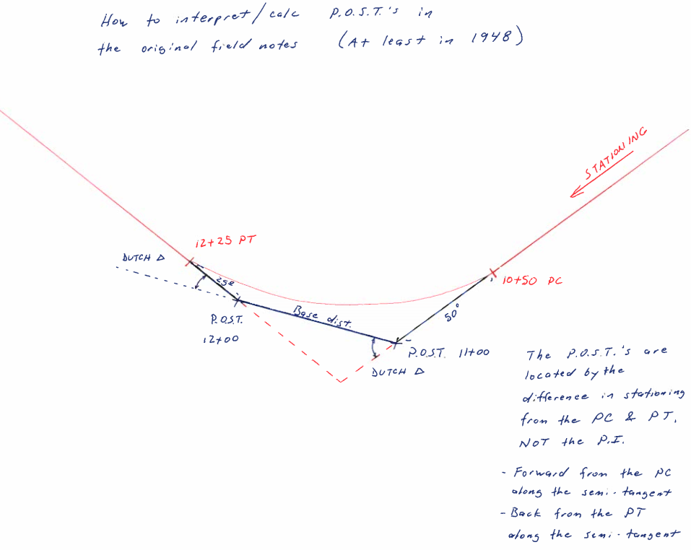

Plats and unrecorded plats in Public Works:
- Hard copies of recorded plats are available by plat name in the cabinets. Not all plats are included, so it is best to get any plats from the Auditor. Some of these have original signatures and seals on them. Not sure what this means: whether they are originals or original copies.
- Hard copies of unrecorded plats are available by plat name in the cabinets (hidden amongst the recorded plats).
- Hard copies of unrecorded plats may also be available in the unrecorded surveys section.
- It is best to look for unrecorded plats in both “unrecorded surveys” and “recorded plats”, as it may have been filed in either location

Unrecorded Surveys in Public Works research room:
- Hard copies of unrecorded surveys (maps) are available by Section Township and Range in the hanging files
- Some I-5 Washdot plans are available in the hanging files – it is best to contact WSDOT for these
- Longview Fiber corner records are available (hard copies) on the west wall cabinet
- DNR Corner records (older) are available (hard copies) on the west wall shelf. I’ve noticed a couple instances where these will not show up on a search of the DNRs website (though it is rare).
- Private surveyor corner records (for timber companies and others) are available on the west wall shelf
- County Survey Book - 1885 through about the late 1950’s.
  - Prior to the 1973 mandatory survey recording act, the County Surveyor’s Offices (in 1907 the title was changed to “County Engineer”) was the only place to file your survey in this state (though it wasn’t mandatory for private surveyors – just County Surveyors). In 1895, the County Surveyor’s Office was charged by state law with recording, in a book, any surveys done by the County Surveyor or any of his deputies (except for those for Highway Plats or City Plats), and any surveys by any person that appeared to meet the standards for surveying, provided that they pay him a fee (the same as the County Recorder). Prior to that (as of 1855) he was charged with keeping and passing his maps/notes on to his successor.
  - The 1895 law also had a retroactive clause that required the County Surveyor to take any field notes in his possession (from past County Surveyors) and turn them into surveys in this book.
  - Cowlitz County has a survey filing book that was started by FM Lane in 1895. It appears that Lane also added several earlier surveys by himself, BF Ivie, and others (from about 1885-1895). After Lane, some County Surveyors used the book regularly, and others have none or very few included (thought they have many surveys located elsewhere in the office – my best guess is they felt that they complied with the law as long as they created an actual map, and had it somewhere in the office). Several of the surveys were completed for court cases. Private surveyors also added surveys to the book (it wasn’t mandatory for them, so there are fewer of those).
  - There are two books that contain and index about 200 surveys.
    - Index maps – showing where surveys were done (by page number)
    - Actual surveys book
  - Many of these County Surveys are sectional breakdowns and show set monuments, as well as detailed maps and field notes.
  - This book has been scanned in its entirety (except for blank pages), has been indexed by STR, and is available for download. A digital copy was given on 2/29/2016 to the DNR PLSO, and will be added to the County’s Lazerfiche system as staff has time. Photos of the original index book are also available digitally.

Unrecorded Surveys in Map Cases (long square tubes):
- On the inside door of each case, there is a listing of contents with description and section, township, and range.
- Staff has put together a spreadsheet of all of this, which includes STR, Description, Surveyor (if known), date, if known, etc. This index is available electronically.
- Many of these maps have hand-written notes on them (done after the original work) that can be immensely helpful.
- Some of these maps are very old and fragile. We have started scanning the smaller, less fragile, and easier to handle maps. Currently, we are in talks with the DNR to scan the more fragile ones, and ones that are too large to fit in our scanner.
Currently, we have scanned most of these maps (those that aren’t too fragile or too big for our scanner), and are in the process of indexing them onto the server.

At some point in the future, my plan is to consolidate all of the unrecorded surveys into one file/database by STR to make searching much more convenient, though it is a long ways away at this point.

Roadway Establishments:
Many of the early establishment documents (say early 1900’s to early 1930’s) have reference to stone monuments being set at the ends of the roadway. Presumably, these monuments were set underground, and some may be still out there. Unfortunately, we have not been able to find any of these stones up to this point. Nor am I certain how/if these stones were marked so as to be locatable. Larry Higgins (road supervisor and previously survey crew-retired) told me that he remembered seeing one or two of these stones at the end of county roads, and that he was told by the surveyor in charge at the time (Larry Keatley) that there were more set stones out there. The stones Mr. Higgins saw were just little double handful sized ones, sticking out of the ground. The establishment documents were not recorded, so they either show up in the County Engineer’s files, or often were transcribed in the commissioner’s journals. Many have the auditor’s stamp on them, however, it appears that they were filed at the Auditor’s Office, not recorded. Current Auditor’s staff is unable to locate these files. In speaking with Joy (who had been with the Auditor since the mid-late 1990s), she said that there used to be “files” in the Auditor’s Vault. Those files are now gone (she assumed they were archived at State Archives).

A local PLS (Howard Richardson) told me once that he remembered seeing all the establishments sitting in the hallway (one day back in the 1990s) to be purged. My hope is that they were archived but calls and trips to state archives have not turned anything up, so far.

Unrecorded Survey Maps from the 1970s, 1980s, and 1990s:
The annex building next to the main county building on 4th Street. The third floor is the old archives location for the County. Public Works had plans/etc. up there until they moved to their 13th Ave. office. I went up there with Ken Stone, because we still seem to be missing about 25 years of survey plot maps (say 1975 to 2000). We only were able to find three boxes and several old maps that we decided belonged to Public Works. Four of the maps we found were survey maps from the early 1980s. It proves that the maps existed at one point (Ken verified that he saw them over the years), but we still need to figure out what happened to them (assuming they weren’t thrown away).

IT tells me that there are no backups or archives for electronic data prior to the year 2000, so that avenue won’t work to get them back.

Scott found a few digital maps from the early to mid 1990s but just a few, enough to know that they did exist at some point.

Andrew (Alvin) Bystrom private survey files:
Andrew Bystrom was Cowlitz County Surveyor from 1897 to 1901. Bystrom had a few GLO contracts as well, and some of his original field books ended up in the Cowlitz County Field Book cabinets. A couple of these original books went to DNR (who gave us back copies), and others stayed here. According to Chuck Whitten, Bystrom noted things in his original field books (what he actually did) that weren’t anything like what his “official” GLO field note say. I have not found any other “private” field notes or surveys from Bystrom, besides what the County and FM Lane ended up with.

Claud Davolt private survey files:
Claud was the Cowlitz County Engineer/Surveyor for several years (after being an assistant county engineer for many years before that). Claud did private surveys throughout his career at the County, and after. Some of those files and many field books were later donated to the county. They are indexed and kept in the Engineer’s Office. Some of these files contain handwritten legal description drafts and unrecorded surveys. Larry Keatley (local surveyor and longtime county employee) worked for Claud on many of his later surveys (at least since 1966) and can sometimes provide additional information on how Claud did things. Harry Becker also worked with Claud, so if you see Harry’s name somewhere, Claud was probably involved as well. It appears that Russ Bass had these documents at one time, and some of the calc-sheets and surveys are from him, though most appear to have been Claud’s.

We have approximately 20 Claud Davolt Private survey field books, ranging from 1937 to about 1966. We also have one or two books by Harry Becker and Larry Keatley, up to 1971 or so. Becker and Keatley worked for Claud. They also appeared to go by “K & B Engineering” for a time.

GIS has quite a few old linens from the 1940s and 1950s in their main office. Most of these were done by Claud Davolt, but may include surveys by others (not all are signed or initialed). These have been scanned and are available on the Public Works server.

FM Lane private survey files:
FM Lane was Cowlitz County Surveyor from 1893 through 1896, and again from 1901 through 1906. Lane took his field books with him when he left the County. Jerry Olson had the original FM Lane field books that they received from a family member several years ago. They have since gone to the DNR for scanning, and I’m hoping to get the originals back here when they are done with them. These records are indexed by STR (N and E lines). Their index is available on our server – not all books are indexed – there is a list on our server. We also have scans of all of these books (except 108 – it was missing for some reason at the time we scanned them). DNR has a copy of the index and all the field books we were able to scan.

Most of these books are by Lane. A couple were from BF Ivie, and Alvin Bystrom (also past Cowlitz County Surveyors) who gave their notes to Lane after they finished their terms in office (as was required by law at the time).

Road Files:
- Full of good road information collected by Public Works over the years
  - Photos (aerial and stills)
  - Letters
  - Maps, sketches, and agreements
  - Waivers, Easements, and Fee Takings
- Some roads have tax maps in the road file with the document numbers for waivers, easements, etc. hand written on them. These were:
  - Done at various times, by various county staff
  - May not be complete, or could be a snapshot in time
  - Watch out for road name changes and multiple road names/file numbers

Road Name Changes:
  - The current access database for road names and numbers (that is kept up as names or numbers change) is located here: \\adminsrv3\admin\Database Files\Road Log\Road Log.mdb
  - There is no real historic list of name/number changes, except as available in the road files (sometimes a resolution by the commissioners is included, but not normally). There is a list (compiled sometime in the 1970s), but it doesn’t appear to be anywhere near complete.
  - Staff has indicated that Don Day may have had a list of road name changes that he compiled over the years, but it has gone missing after his retirement. If you find it, or have a copy, please let me know.
  - See the latest road log for official current road names.
  - See previous Road Logs for legacy names.
  - See also the large format road map by public works (on the wall in the records room) for current road names.
  - See individual road files for name changes, if available.
  - See the old County Engineer’s Road Index Maps (large format) for indication of previous road names and locations – this is presently your best initial source for road name changes, though it won’t have all of them. These are now scanned and on the server.
  - See also the many roadway maps that have been compiled over the years (1897-present) by County Staff for various purposes. These contain the names used at the time and can be very helpful.
    - I have had as many of these maps scanned and added to the server as possible at the following location F:\General Survey\Survey Research and Indexes\Road Index Maps, as shown below:

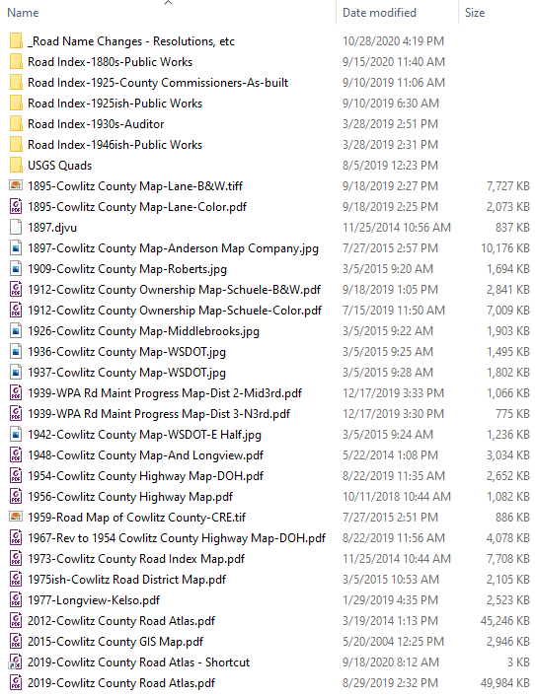

Road Index Books/Maps:
The County Engineer’s Offices in this state have long been required to keep maps in their offices, showing the locations of all County Roads. In Cowlitz County, there are three main sets of legacy maps to show this information, from the 1880s, 1920s, and 1940s. These maps are one of the main ways we have of determining old road names and historic locations. They are located in the same place on our server as the name change information. See above.

Road Logs:
The Road Log is a milepost listing of features along a county road that looks like this:
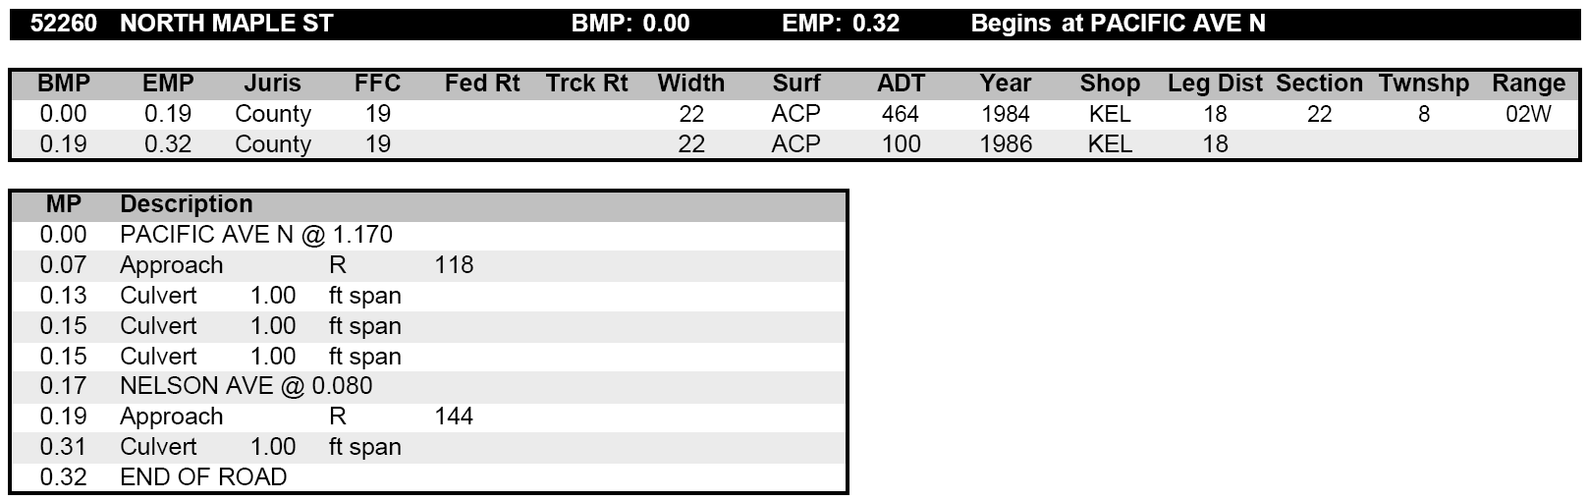

The road logs can be extremely useful in determining where a road begins and ends, what features are along that road, and can indicate changes over time, by going through old logs. I have several old road logs in my office. As we get time, we scan the old ones in. The latest one is 2012, the oldest I have is 1926. The earliest road logs are contained in the survey field books. The first typed one we have is from 1954 and they keep that general format to present. As they are scanned, I have been putting them here: F:\General Survey\Survey Research and Indexes\Road Logs

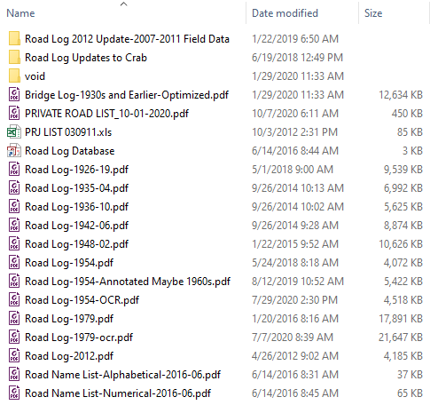

Bridge Logs/Files/Inspection Reports:
In 1907, WA state law (session laws of 1907, Chapter 160, Section 3 – [S.B. 126]) required that the County Engineer “shall at least annually inspect or cause to be inspected, all bridges of the county, and make a report in writing to the board of county commissioners with such recommendations for the repair and maintenance as he finds necessary.”

In Cowlitz County, bridge inspections were typically recorded in the Engineer’s Office Field Books, and can be found by searching the indexes therein (1909-1980s-ish). I have not seen actual reports to the commissioners that the 1907 law indicates, nor have I had reason to track them down at this point.

At some points, they had entire “Bridge Logs” created in field books. These books were separated from the other field books for some reason and currently reside in a box under the desk in my office. I’ve seen Bridge Logs for 1944 and 1948. Not sure if they are complete or not, but appear to contain many bridges. My plan is to bring these into the overall field book index when we have time.

At some point (not sure when) they created a Bridge File for each bridge (located in the research room next to the Road Files). These include inspection reports, photos, and whatever other data was deemed important enough to keep. Bridges that no longer exist or no longer belong to the County have been pulled out and are in boxes. Some or all of these files may be in Laserfiche (not sure).

Road Books:
- There are three books on the shelf on the west wall of the records room labeled “Road Book”. These books contain establishment notes, survey reports, viewer’s reports, etc. for early roadways. These were written by the Auditor and kept in his office, as required by the laws at the time. The ones we have may be copies.
- There is an index for Book 1, handwritten. A scanned copy of this index is available on the server.
- Several of the reports in these books are tied to the large road book via handwritten notes by the Auditor (in the large road book).
- These books have been scanned and are on the server. Indexes are in progress as time allows.
- We appear to have a gap between 1882 and 1885. I’ve searched in the County Museum but didn’t find anything.
- “The Archives of the County Records of Washington – No. 8 – Cowlitz” WPA 1942 indicates that there should be four of these books (possibly one was a partial copy of one or more of the others?). Again, we only have three that I am aware of.

Roadway Maps/Plans:
(can also be considered unrecorded surveys and are integral to the field notes)
- In hanging cabinet on south wall and/or the server and laserfiche
- By road number (list is available)
- May show monuments or ties not recorded, especially when used in conjunction with the field notes
  - County engineer does not need to file as long as map is available in the county engineer’s office
  - Many times, the field book number is written on the plan somewhere (usually in the title block on the left-hand side)

Roadway Vacations:
- There is an index of Road Vacations available as an Excel spreadsheet on the Public Works Research page.
- Resolutions for ALL the vacations appear to be on the Laserfiche files (under Roads Admin). It doesn’t appear to be searchable by road name, but seems complete (use the index spreadsheet to figure out which one you need).
- Commissioners’ journals are where most of these were approved. Some CCJs are referenced by book and page in our Road Files or other indexes. There is an index of vacations in the pull out drawers on top of the map case next to the rear door of the building.
- These were traditionally recorded/filed in the County Surveyor’s/Engineer’s/Road Engineer’s Office, as was standard of the day (it appears that the Auditor also kept filed copies in his office – not sure on the end date of that). After the 1989 Ellingsen Court Case, they were recorded in the Auditor’s Office and any new ones are recorded at time of vacation.

Volcano Roads:
After the Mt. St. Helens Eruption in 1980, several roads became unusable due to mud flow deposits or were washed away. If you are working in the unusable portion of one of these roads, please speak to the County Engineer for more information. Some of these roads are:

Fiest Road
Cook Ferry Road
Toutle Park Road
Toutle River Road (#4)
Tower Road (now Storm)
Otto Cook Road
Maple Flat Road
Wheeler Road
River View Drive
Stillmeadows Lane

1980s – 1997 survey maps:
Prior to the advent of the data collector, modern EDMs, etc., most of the County Surveys were included in the road plans. Meaning that one can read the field notes and trace where they are on the road plan. Sometime around 1975 (when the county got a theodolite and distance meter and started doing radial surveys) this practice stopped, and they started having separate survey drawings/sketches from the Road Plans. Unfortunately, most of these survey drawings are unavailable at the moment. I’ve been to State Archives, the old County Annex, and the County Museum, but have so far found very little (half a dozen maps out of what should be several hundred). Because of the “new” way of surveying with an EDM, there was typically no way to follow the field notes on the Road Plan without the survey map (they started using point numbers instead of stationing in their notes). You can still figure out what they tied, but you will need to redo their entire survey and plot out all of the notes. Obviously, this makes utilizing surveys from this era cumbersome at best. Also, during this time (and until I arrived in 2012) it was standard practice not to note all set monuments in the field notes. Prior to this time-frame (say pre-1975), the field crew traversed, calced, and set their monuments at the same time (during the project), so set monuments appear in the notes (or were inferred in the notes). During this time (post 1975), the office calced most of the Monuments to be set, so they don’t show in the notes. This means that without those maps/sketches, we have no idea what they set or where they set it. Due to this last point alone, I am extremely motivated to find these old surveys/maps/sketches, and will continue to utilize any resource I can think of.

So far, I have looked on the 4th floor of the old County Courthouse (the old jail), “small claims” under the north stairs in the old Court House, the upper levels of the annex building next to the old Courthouse, Building and Planning (the old Public Works location), and Public Works’ current office. I’ve gone to state archives, and I’ve spoken with many people who were in Public Works in those days (including Kent Cash, Ken Stone, Jodi Spahman, etc.) but no one seems to know what happened to them.

Segregated Construction Field Books:
There are three old boxes of field notebooks in the records room that we need to go through someday. They appear to be County Engineer Field Books for bridge inspections, general construction, manhole dips, and road inventories, prior to the 1970s. I had someone scan through them and pull out anything that seemed relevant to surveying, which are now in the Field Book cabinet and are in the index and have been scanned. The rest seem to be pertaining to construction of one sort or another. Not sure why they were segregated from the other field notes. See Road and Bridge Logs.

Professional Land Surveyor Surveys (1998 to 2011):
Public Works hired a professional land surveyor to oversee its surveys in 1998. Prior to that it was done by various county staff, at the direction of the County Road Engineer. Fortunately, most of these Engineers were also competent surveyors (to the various laws of the day) as is the historic nature of the office until recent times (after 1978). Donald Lee Day was the Public Works Land Surveyor from 1998 to 2011. Don amassed a huge amount of work over the years. In utilizing Don’s surveys, please remember:
- Because Don worked under the authority of the County Engineer, most of Don’s surveys weren’t recorded in the Auditor’s Office. They were filed in the office of the County Engineer, per the ROS exception in state law. You will need to contact Public Works to search the hardcopy and server files.
- Many of these unrecorded surveys are only available in CAD format (mostly Autocad LDD), though some of the last ones were done in Civil 3d.
- Most of the Autocad drawings (unless it was something he intended to file for the Auditor) do not have:
  - Any notes on them as far as how he resolved something.
  - Basis of bearings and coordinates.
  - Monument notes beyond the autocad point description, which isn’t the full description of the point.
  - Where it is located.
  - Road names (other than as listed in the file name).
  - These were done strictly for the engineering department, who already knew this information, or was provided it in person.
  - Don kept detailed hard-copy files of all his projects, so you can go through the hard-copy for notes, waivers, deeds, etc., which will allow you to figure out how a particular resolution was done.
  - Don’s hardcopy files are available in my office, in four filing cabinets and are indexed by road/project name.
- Most of the record that Don used for these road surveys came from Public Works field notes and files. It was considered filed/recorded information, so would not need to be refiled/rerecorded.

Don’s electronic files are available on the public works server and are indexed by Road/Project Name and/or County Project Number. A global server search for road name and project number usually works best for finding these surveys. Again, most of them were unrecorded (at least with the Auditor), but are indexed on the server, so they are there, and available.

I have started creating a location based (GIS) database of many of these (and ongoing) projects, utilizing Google Earth for the moment to “pin” county projects. This can be a quick way to figure out where Don has done work, though it is incomplete, and probably won’t ever be complete, as it is simply intended to help myself and County staff figure out where relevant projects are (as we need them). We aren’t actively cataloging old projects at this time.

As I find them, I have been making copies of Don’s non-Auditor’s Office, Road Engineer’s Office recorded surveys (signed and stamped) and putting them onto the server (F:\General Survey\Survey Research and Indexes\Unrecorded Surveys\Don Day)

Current PLS Surveys:
I was engaged (on an as-needed basis) as the consultant land surveyor to Cowlitz County Public Works, between June 2012 and December 2014.

I am now engaged as the full time Professional Land Surveyor for Cowlitz County Department of Public Works, and have been since January 2015.

I have tried to put all of my projects into a GIS database in Google Earth. Most actual survey work that I’ve done for the County should be in there with job name, county project number (if it had one), and whatever other notes I could add to aid in finding the data. My other projects (mostly research and review) are not included in this database.

I am trying to record as much as I can with the Auditor’s Office (instead of just filing it in the Engineer’s Office, as was done in the past) – assuming it is something that should typically be recorded. If the ROW is already well documented (either at the Auditor or in the Engineer’s Office), then I file copies (digitally and in hard copy format) of the stamped final topo and/or boundary drawing in the Engineer’s Office. On some projects (at the beginning of my time here), the County asked me to write memos detailing what I did and why. These will be in the project digital file and/or in the hard copy file. I have been creating hard copy brown files, using the previously setup filing system by Don – indexed by Road or Project Name, in the same filing cabinets he used, which are currently located in my office.

My filed, but unrecorded, surveys are being saved in the following place on the Public Works Server: F:\General Survey\Survey Research and Indexes\Unrecorded Surveys\__Non Recorded Projects-Post 2012-06, and are available for public inspection, as required by RCW 36.80.015.

Legacy Vertical Control:
- There is a drawing in Autocad C3D format available in public works that has many past (pre-2012) control points on it that the previous surveyor put in from his past projects (and from past GIS projects).
- There is an Access Database Available in Public Works that has some of these control points in it (the ones that Don leveled through). Currently, this database has limited functionality, as it was created on a very old version of Access.
- There are hardcopies of several level runs with photos, descriptions, etc. available in Public Works (in the County Surveyor’s Office). We’ve also scanned these books, which are available on our server.
- All of these points have been put together over time and may or may not be relevant or accurate for your purposes. It is your responsibility to check with other source data, shoot multiple benchmarks as a check, and/or use GPS to verify position prior to use. Public Works does not check these monuments for subsidence, movement, etc.
- These old benchmarks is a legacy data set. Public Works no longer adds to this data set, nor maintains or supports it. If you come in looking for something, we will provide it as public information but be warned that it may not work for your purposes, and there may not be metadata available regarding its original reliability. Many of the points in this system were created by GIS for aerial targets (utilizing fast static GPS procedures – 20 years ago), and the elevations are not very reliable. Be very careful if using this data.

Aerials:
- Hard copies of various aerials are available in the records room
  - 1950s era (1948 to 1960) photos
    - In books above the road files
      - These are up on the top shelf in the records room in black books by STR
      - Summer help has scanned them onto the server, and put copies into Laserfiche
      - Arranged by Section Township and Range
      - Sometimes have dates handwritten on them
      - Most are not dated
      - There are some overlapping photos of the same area (usually from different time periods)
  - 1963
    - See ’63-‘68 index map in the corner leaning against the west wall shelf
  - 1968
    - See ’63-‘68 index map in the corner leaning against the west wall shelf
  - 1974
    - See ‘74 index map in the corner leaning against the west wall shelf
  - 1988
    - See ‘88 index map in the corner leaning against the west wall shelf
- There is an exhibit map of existing aerial data by GIS on the PW server
  - Not all of it is available to non-county staff due to interagency agreements to only use certain data and not share it with others. Only affects some of the FEMA mapping that I am aware of.
- Corps of Engineer’s Aerials:
The corps of Engineers flew aerial photo missions for high water/flood years back to the late 1920s. So far, I have been able to obtain images from 1929, 1933, 1939, 1948, and 1957, for areas along rivers, such as the Lewis, the Columbia, and the Cowlitz. They charge for private requests, but not for public. They don’t want us sharing the aerials we get for free with the Private Folks (there is an agreement to that affect between the County and the Corps – through GIS). The contact I have been using is:

Chris Edwards (503) 808.4820
Chris.B.Edwards@usace.army.mil
U.S. Army Corps of Engineers, Portland
CENWP-EC-TG
333 SW First Ave
Portland, OR 97204
503 808 4820
(fax) 503 808 4805

Diking District Records:
The County Engineer’s Office has long been a partner with the local Diking Districts, providing engineering support and oversite as needed. Due to this, The County has a large number of Diking District records in its collection. This includes:
- Maps
- Correspondence
- Waivers/Deeds/Easements
- Document reference sketches
- Construction plans
- Field notes

The County also has microfilm that came from Cascade Title, along with an old index book. The microfilm (rolls 401-404) contains establishment documents and maps for the diking districts that used to be “filed” in the Cowlitz County Auditor’s Office.

Other Cowlitz County Departments

Cowlitz County Auditor’s Office:

Auditor’s Road Record (aka Auditor’s Road Book)
- There was an old book labeled “ROAD RECORD” in the NE corner of the Auditor’s research vault (that went to State Archives in June 2020). This book contains a listing of old roads, showing their establishments, references to Commissioner’s Journals, etc., with sketches of these roads by Township and Range (in the back). This book has been scanned and is available on the Public Works Research Website. It is also digitally available at the Auditor’s Office.

We are breaking this book up into pieces (digitally), as we have availability, and are putting it into the County’s Public Works Laserfiche Road File System. These will be placed under (Right of Way/Establishment) and will have Aud Rd Bk in their title. Most have not been added to their roads at this point, so you will likely have to ask us for them.

As far as I can tell, this has been public record information (if not recorded to the standards of the day), and available at the Auditor’s Office since the early 1930s, when it appears this book was created by them (possibly as part of a WPA or other “make work” project) and was there in hard copy form until June 2020 (and is even now available there in digital format). The last entry in the book appears to have been March 5th, 1941, so if you have a pre-WWII road, you should probably check in this book, as it will likely be there.

- This book has an alphabetized/then chronological index in the front (the first 25 pages or so), information regarding Commissioner’s Journal Entries and the like in the middle, then index maps in the back.

- The Road Book also has a hand-written index of recorded documents for various roads from the 1890’s to about the mid-1930s. This index is on yellow paper in the Book’s pockets. This is also scanned and available on the PW server (not online).

Assessor’s Property Index Books (Tract Books)
These were the giant green books that were available on the left side, when walking into the Auditor’s records room vault. These have since been moved to the Public Works Admin Building. Not sure how long they were stored in the Auditor’s Record Vault, but since at least 2012 when I started working with The County.
  - Indexed by STR and DLC and/or City
  - Great way to do a quick chain of title by location (instead of Grantor/Grantee)
  - May not be complete, but can be a great place to start
  - Seems to include many original road waiver references for early roads (this doesn’t appear to be the case later on). Not sure what the time periods were for indexing waivers, but it seems that they stopped sometime in the 1940s.
  - Public Works has amassed a collection of photos of the pages of this book, as we need to for projects. These images are not the greatest quality, and some of the page is usually missing (the names and document numbers part is there though). It is available here: F:\General Survey\Survey Research and Indexes\Assessor Deed Books
  - Public Works Summer Help has begun scanning these books in high resolution onto our server. We have finished the County-wide books, and City books for Castle Rock, Kalama, Kelso, and Woodland. We recently started scanning the Longview books, which will take the greatest amount of time.

Assessor’s Abbreviated Deed and Superior Court Case Books
  - The Assessor’s Office kept abbreviated copies of deeds and court cases related to property rights. There are dozens of books, spanning a long period of time. These books are in the Auditor’s Vault near the break room.
  - These books have since been moved over to Public Works.

City Ordinances
There was a book in the records room (left hand side going in) above the Surveys that has ordinances for streets, etc. listed by City. Done sometime in the 1950’s. This record is not complete, but can be immensely helpful. This went to State Archives in June, 2020. I was unable to obtain scans before it left, though I will put it on my list for when I next need it for a County project.

Establishments, Waivers, Surveyors Reports, etc
The Auditor’s Office used to keep copies of these documents (according to staff, and some evidence I’ve seen in our road files). They had “files” that used to be in their downstairs research room, prior to it being cleaned out and repurposed for the print shop, sometime in the 1990s or early 2000s. According to a land surveyor contact the establishments, etc. were piled up in the hall to be purged, along with some old Davolt maps. We’ve determined that the Davolt maps went to GIS. Not sure what happened to the establishment documents. Archives has not been able to find them in their records.

Grantor/Grantee Deed Index Books
- Hardcopy index books by Grantor or Grantee (Direct and Indirect). These were sent to State Archives in June 2020, as the Auditor sent them there to transition to digital only in-house copies, which are not available at this time.
- These are the original index books for Cowlitz County Recorded Documents. There are other sources to find ownership information (assessor’s tract books, title company, etc.) however, these books are the official record and sometimes contain additional notes not in the other sources.
- Public Works has a digital copy of the 1855-1890 Direct and Indirect Index books on its server that is available. Unfortunately, that was all we had time/staff to scan when the books were leaving the County.
- You will need to contact state archives and request access to these books in person or photos of the pertinent pages. For research requests or information concerning local records management, please email research@sos.wa.gov Jewell Dunn is who I’ve worked with the most there, on these sorts of requests, and she is familiar with our Auditor’s records.

Plats
- Hardcopies by Plat name/number
- Electronic index and database via computers in research room (Eagle Recorder - this can be searched by STR). Is this still available?
- Plats are available online at the Auditor’s Research website: http://apps.co.cowlitz.wa.us/weblinkAuditorPublicRecords/welcome.aspx?cc=1
- DNR Webextender website. This may be the best way to search for Plats Digitally if you don’t have access to Eagle Recorder.

Records of Survey
  - Hardcopies by STR in the Auditor’s Office. These were sent to State Archives in June 2020, as the Auditor sent them there to transition to digital only in-house copies.
  - Electronic index and database via computers in Auditor’s research room (Eagle Recorder - this can be searched by STR). Is this still available?
  - Surveys are available online at the Auditor’s Research website: http://apps.co.cowlitz.wa.us/weblinkAuditorPublicRecords/welcome.aspx?cc=1
  - DNR Webextender website. This may be the best way to search for Surveys Digitally if you don’t have access to Eagle Recorder.

Cowlitz County Commissioner’s Journals:
The commissioner’s journals start in 1855 and continue through present. These records have information on roadway establishments and vacations, plat approvals and vacations, county property boundaries, and a host of other things related to county and private property. These records are sometimes the only location of information regarding a particular roadway, as many of the approvals were not recorded in the Auditor’s Office. If you think something is missing from the road file regarding a roadway establishment, roadway vacation, plat vacation, etc. then you need to request to look through the Commissioner’s Journals. Public Works cannot allow outside access to the files (due to privacy concerns), but you can access them through the County Commissioner’s Office. We are adding these records to the road files as we obtain them for projects.

There is an index that Ken Stone put together showing dates for the various Commissioner’s Books, and dates of commissioners service, which can be extremely helpful.

Cowlitz County GIS:
Jim in GIS has been there for over 20 years, and is a wealth of information. He knows where most things are/were in the county, in relation to maps, recent survey history, etc.

GIS has a couple garbage bags with George Raper maps in them. I reviewed what is there, and it looks like mostly blue-lined copies of recorded maps. Some linens or mylars (of topos) are included, but there is no index to know what you are looking at. It also appears that the bulk of the George Raper boundary maps were sent to DNR, so there probably isn’t much in there that can’t be found elsewhere in an easier to research format.

    - GIS has current Road Atlases for sale to the public

GIS has quite a few old linens (and on other media) from the 1940s and 1950s in their main office. Most of these were done by Claud Davolt, but include surveys by others (or have no signature). We have scanned these, and they are available on the Public Works server.

GIS also has a bunch of general unrecorded maps (private surveys, railroad maps, etc.). These are roughly indexed and available in their main office as well.

I also found a random garbage bag of K&B Engineering stuff outside of the GIS cage, near the elevator (at the outside window) on the top floor of the annex. It didn’t seem too valuable, but you never know. No index found. If we have time, I’ll send someone to take another look and scan anything that looks useful.

Cowlitz County Historical Museum:
The County Museum houses a large number of maps, oral histories, etc. that can be useful to the surveyor. Many of these maps came from Public Works or other departments in the County. Some maps were probably things that Public Works wanted to keep, but other departments gave to the museum, not realizing what they were (from conversations with Ken Stone and others), which means that there are probably many useful items in their possession. Claud Davolt was a founding member of the Museum, so who knows what he gave them. Bill Watson is the person to talk to about maps and documents in their collection. I have found many useful maps and records there…

Cowlitz County Superior Court Orders (SCO):
Superior Court Orders pop up on GIS quite a bit for divorces, boundary disputes, etc. These cases are sometimes recorded in the Auditor’s Office, but most often not. Therefore, one needs go to the hall of justice and request a copy.

SCOs are available on Laserfiche (back to 1983) for County legal staff. Other County staff can call and request copies be sent over.

For private surveyors: There are several books of SCOs (in abbreviated format) in the bookshelf just inside the breakroom in the Auditor’s Office Vault. Otherwise you’ll have to contact the Superior Court directly to obtain copies.

These books are now (as of September 2020) available at the Public Works Admin Building.

Other Sources of County Research

CDID#1 Headquarters:
There is a massive collection of old maps at CDID#1. Most of these maps have something to do with the dikes out in that area. However, according to Judy Strayer, District Manager, their surveyor for many years (Bob Carpenter, PLS 19616) obtained many maps from the County when they were purging old files, so there are also aerials and general mapping documents, and may be other stuff. There is an index available on the Public Works Server (or by contacting CDID#1 directly).

In speaking with Mr. Carpenter, he confirmed that there was a massive purge of old survey related documents and maps over at the court house sometime in the 80s or 90s. He was able to rescue CDID#1 files, but nothing else. I’m guessing that this is what happened to the Diking District files that seem to be missing from our records (for all the other districts besides CDID#1). Hopefully, some or all of this went to State Archives or the Museum, though nothing has turned up as of yet.

City of Woodland:
According to conversations with Rob Vanderzanden (past Public Works director, and City Engineer for many years) he was the last person who really knew where the documents for surveys and maps at the City were. As far as I know, there are no PEs or PLSs working at the City currently and they are contracting out for these services (no idea on what they are going to do about their records). My contact at the City is:
Kathryn Myklebust, Engineering Aide
City of Woodland Public Works
Office: (360) 225-7999
Fax: (360) 225-7467
300 East Scott Ave
PO Box 9, Woodland, WA 98674

Corps of Engineers:
Many of our diking districts have data at the Corps of Engineers. Most of the records are in Portland, because we drain to there, but some may be in Seattle. Here is a contact that I’ve used successfully in the past to obtain aerial photos. I’ve gotten photos for big flood years back to 1929.
Information on how to obtain historic aerial photos from the Portland Office is here: https://www.nwp.usace.army.mil/Library/Aerial-photos/

DNR PLSO:
Currently, I am working with the DNR PLSO to get digital copies of Public Works records into their hands as a backup (as we have them). I have started uploading files to their FTP site. So far I have given them copies of our:
- Field notes from 1885-1990, including our latest index
- Unrecorded Surveys (Hanging Files) including our STR index
- Unrecorded County Survey Book (1885-1950ish)
- FM Lane field books and index
- AE Shulz field books, surveys, and index
- WSDOT field books
- WSDOT “Hard Shells”

The DNR PLSO has many files that aren’t available in the County archives (Auditor, GIS, Public Works, etc.). It is highly recommended that you also utilize their resources when doing projects in Cowlitz County.
  - They have many old railroad maps, field notes, RR exhibit maps that aren’t in the County Road Engineer’s records.
  - Some diking district exhibits and maps have made it into DNR PLSO files that are no longer in the County. These may have been sent to archives, or lost when the files were out of County hands (there were several times over the years where the documents went back and forth between the Diking Districts themselves and the County). They also may have been thrown away in the 1980s or 1990s per conversation with Bob Carpenter (see CDID#1 discussion above).
  - They have quite a few maps for proposed roads back in the1920s – 1950s. These maps appear to have been made by Public Works, and have corner information on them, but are no longer available at the County (as far as I have been able to determine).
DNR PLSO Website, where you can find a link to Webextender (Username: PLSO, Password: PLSO): https://www.dnr.wa.gov/public-land-survey-office

Longview Library:
The Longview room of the Longview Library has a collection of documents and maps from the Longbell Lumber Company, dating from the 1920s and 1930s. In speaking with the librarian responsible for this collection, and a quick view of the room, there would appear to be many maps and documents that would be of interest to surveyors, especially in regard to the dikes and properties out in the Willow Grove area.
http://longviewlibrary.org/longviewroom.php

There is an online presence for the old photos in this collection. These can sometimes be helpful as they may show what certain roads and properties looked like in the past. It is here, and is searchable: http://contentdm.longviewlibrary.org:2011/

Longbell Monuments:
In particular, Longbell had monuments set for many of their projects. There is a list of coordinates in public works of many (maybe all) of these monuments. There is a large map at the County Museum from the 1920s that shows proposed Longbell properties and property options. A digital copy of this map is available on the Public Works server (with said coordinate sheets tacked on the back). The 1940 Trantow map also shows many of these monuments. Copies of the Trantow map are in the Cowlitz County Museum, and County Assessment.

Port of Woodland:
According to a conversation that Chad had with Jennifer Wray-Keene, Executive Director at the Port of Woodland in November, 2020, there was a flood several years ago (before she worked there) that destroyed most (if not all) of their survey records. It would be nice to get confirmation of this from someone who was there at the time and what (if anything) was saved.

Washington State Archives:
Security Microfilm
There is quite a bit of information at State Archives. It appears that many records in Public Works were microfilmed and sent to archives in 1981. These films are available to retrieve from Central Microfilm Archives, as required.

We have a copy of the index of what state archives thinks the Auditor and Public Works has in microfilm archives. These indexes are on the server.

Our latest contact has been:

Ann Elkin
360-753-0740
ann.elkin@sos.wa.gov
securitymicrofilm@sos.wa.gov
Washington Secretary of State/Security Microfilm
1129 Washington Street SE
Olympia, WA 98504-0238

Also, there is an index in the Auditor’s Office that says that the engineering documents were microfilmed onto 35mm rolls in 1960 (township books, surveys, engineering projects, etc.). This film was reportedly kept in the Auditor’s Office until 2007, when they redid their records room and sent a bunch of stuff to State Archives. Unfortunately, State Archives hasn’t been able to find these films, so I’m not sure if they were sent to the state, or filed somewhere else (Public Works, GIS, or Planning seem the likely candidates). I’ve spoken with Planning and GIS, and have gone through Public Works files, but no luck so far. In speaking with Ken Stone, he thinks that these microfilms were in public works possession at one time. Whether they are in the annex, in the file storage at the public works building, State Archives, or somewhere else, he didn’t know. Searches at all the before-said locations turned up nothing.

SW Region Records (Olympia)
For hardcopy documents our records go to Tracy Rebstock at:
Tracy Rebstock
Washington State Archives Southwest Regional Branch
1129 Washington Street SE
Olympia, WA 98504
(360) 753-1684
Business Hours Monday to Friday 8:30am to 4:30pm

There are two boxes of waivers, maps, and documents available at SW Region Archives. An index of what is in each box is available on the server. It appeared to be mostly old stuff that no longer really applied to current roads any longer. They may have been vacated, or files of facilities that Public Works no longer owns or maintains. I need to go back and revisit this sometime, now that I know much more about old records in the County.

Auditor’s Deed Documents and Plats
In 2020, the Cowlitz County Auditor’s Office transferred all of their hard copy documents to State Archives. This includes their Grantor/Grantee Indexes, Deed Books, Microfilm Records, Hardcopy Maps (ROSs, Short Plats, and Plats), Road Record, etc. They also kept the Assessor’s House Sheets there, which were boxed up and sent to Archives as well.

To obtain copies of pre-1980 deed documents, which are not on the Auditor’s Website, I usually send them an email at research@sos.wa.gov, and one of their researchers will get back to me. Typically, they get back to me in a day or three when it comes to copies of deeds. Having them go through the Grantor/Grantee index typically takes a week or two. If you wish to go in person, I suggest calling ahead and letting them know what you need, as some of the indexes/documents are kept in offsite storage and require some time to retrieve. The people I usually hear back from are Jewell or Tracy.

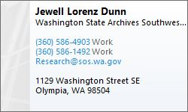

Local Land Surveyors and their pre-1973 records:
(Alphabetized by last name)

Andrew (Alvin) Bystrom
Information that I obtained from Arden Stocks (he knew the family) is that Bystrom was in business with FM Lane and that the two of them met somewhere before coming to Cowlitz County (possibly working together at a RR company). There are some GLO field books in our regular Public Works field books cabinets and index that Bystrom/Lane appear to have done for the GLO out in the east side of the County. See Public Works Field Book Index. One or more of Bystrom’s field books appear to have ended up in the FM Lane collection as well. The Woodland Museum has photos from FM Lane’s RR days that appear to have Mr. Bystrom in them too.

Robert (Bob) M. Carpenter (PLS 19616)
Bob is a local surveyor, retired, who worked for CDID#1 for several years. He also worked for Cowlitz County for awhile. Bob rescued many old documents from the County Assessor’s Office, Auditor’s Office, and other purges of data in the 1980s-1990s.

In speaking with Bob, there was a very large purging of old documents back in the 1980s-1990s by one of the Assessors/Auditors, who destroyed many of the really useful maps in the County’s possession at that time. Bob took a large number of documents related to CDID#1 and that general area and these records are now housed at CDID#1. Unfortunately, he believes that many documents related to other portions of the County were thrown away in these purges.

Archie B. (Brent) Carpenter (PLS 16196)
According to Karl Germunson, Brent Carpenter (AKA Archie B. Carpenter) was a surveyor in the area that worked for Weyerhaeuser for many years. My understanding from others is that Mr. Carpenter is still around in the area. I do not have contact information for Mr. Carpenter, nor have I spoken with him about what pre-1973 records he may have. I understand that he took Arden Stocks on quite a few corner searching missions up on Mt. St. Helens, back in the 1980s.

Claud Olson Davolt (PLS 328)
Most of Claud’s public files are here at the County. Many of his private files and surveys are here as well. Arden Stocks had (at least at one time – he can’t find it now) a taped interview with Claud that would be interesting to listen to and have a copy of for the Museum, if it still exists.

Eric C. Feasey (PLS 7370)
Mr. Feasey worked for Crown Zellerbach until 1985. Then it appears that he retired and had his own company named Forest Engineering Services, and stamped work (or also worked for) Centerline Cartographic out of Longview and Castle Rock. Looks like Alan Grant worked with Centerline Cartographic as well – need to ask him about it sometime. It appears that Harry Salo may have worked with Feasey at Crown Z also. Alan Gollersrud (who used to work with Feasey) ended up with Feasey’s records. Brandon is trying to see if we can get them into our collection. Not sure if there is anything pre-1973 in them or not.

Karl Germunson (PLS 38958) Dorell Germunson (PLS 10997)
Karl is a Land Surveyor, currently working in the County, in private practice. His office is in Castle Rock. His dad (Dorell) worked privately in the area since the 70s and worked for Weyerhaeuser before that. Besides Dorell’s pre-1973 survey records, they have Vickers records, and various other bits and pieces: Weyerhaeuser stuff, Brent Carpenter stuff, field notes from the 1922 Kalama shoreline mapping, things they saved from being thrown out at Cowlitz County, etc.

LC Gibbs (PLS 936)
See Gibbs and Olson records. Unfortunately, someone threw out the majority of the pre-1973 records while the PLS was out on vacation. Some records are available at Foresight Surveying in Chehalis. Ken Frasier (he owned foresight before he sold to Goodman) up there bought the Lewis County records from G&O back in the day. According to the G&O PLS, if there was a Lewis County Job in an old field book, Ken got it, even if it contained mostly Cowlitz surveys, so it is possible they have quite a bit of information.

Erland V. Hill (PLS 7591)
Hill’s records went to Clark County. Mike Gilroy (the surveyor who indexed them for Clark County) says he sent the Cowlitz ones here. Can’t find anything specific around here. Not sure where they ended up, who got them, or what they did with them. Since I’m not sure exactly what they looked like, it may be that they are already here in our collection somewhere.

Uuno Gustav Jackson (PLS 462)
UG Jackson was a private/public surveyor/engineer working in Cowlitz County in the late 19teens to the late 1930’s. He was previously the Clatsop County Surveyor – 1910-1915. He was City of Kelso surveyor from about 1920-1924, when he left the City to go into business with Middlebrooks. Jackson was diking engineer for several districts in the area. He has a couple of field books and several drafted survey maps recorded in the Cowlitz County Engineer’s Office, which also has references in County field books to other prior surveys/field notes of Jackson’s that aren’t here. Sometime in the late 1930s, it appears that he went to work for the USACE in the Portland District. I need to speak with the Corps to see if any of his records ended up there. He may have also had EA Middlebrook’s records, as Middlebrooks died in 1939, so it makes sense that they would have gone to Jackson. I’m hoping they are sitting in a box at the Corps somewhere. Chris Edwards at the Corps gave me a contact for their librarian (Jennifer Muller). I need to follow up with her when I get a chance/reason to dig further.

Rae L. Johnson (PLS 1786)
According to others, Ray Johnson was a surveyor who worked in the Cowlitz Area in the 1920s through the 1980s and for Weyerhauser and International Paper. When he passed away, his stepson, Darren Darby, took his files. Darren now lives in Montana. I have not been able to get in touch with Mr. Darby to inquire about this collection, though I left a couple messages at a phone number I was given.

Stuart (Larry) Keatley (PLS 37552)
Larry worked for Cowlitz County Public Works since the mid-1960s as a construction inspector and survey field crew. He later got licensed as a Land Surveyor (2001). He worked for Claud Davolt on occasion, back in the 1960s. I don’t think he has pre-1973 records, but he does know quite a bit about Claud and the past Public Works survey staff. He also worked with Harry Becker and Claud Davolt back in the 1960s and 1970s on non-County work.

J. Frank King
King performed the timber cruise and topo survey for Longbell (either just prior to or after their timberlands purchase). The museum has at least one book of this information. Need to get down there someday when I have time to figure out more about King and his surveys. Are there actual survey maps related to these books?

Fred Milton Lane
Was County Surveyor, County Commissioner, Diking District Commissioner, Diking District Engineer, off and on over his career. His surveying in Cowlitz County appears to span from the early 1890s until 1933, when his field books stop (at least the ones we have). He had a farm out in Woodland Bottoms and seems to have done quite a bit of surveying there, including for Poysky on the original Dike survey. See here for more information on his County Records. The Woodland Historical Museum has a large collection of photos and stuff from the Lane family (including Lane’s Transit). Erin Theony is who I speak with there when I have some questions about Lane. Haven’t had a chance to go see their collection in person.

G.K. McKensie
Arden Stocks has some of his records that were sitting in a box in the basement of a house he bought many years ago (the ones that hadn’t turned to dust anyway). I don’t know much about McKensie yet. Will add more as I learn it from Arden.

Ernest A Middlebrooks (PLS 206)
County Engineer for several years. Also in private practice with UG Jackson for several years. Was diking engineer for several districts as well. Can’t find his records. Maybe they went to Jackson after his death in 1939?

Rhoades Thomas (Tom) Morgan (PLS 12334)
Mr. Morgan worked in the area and recorded surveys here. I don’t know much about his pre-1973 surveys (if he has any). Karl thinks he has some though. I’ll have to do some research one of these days.

Nick W. Nicholson (PLS 13064)
Academy Surveying in Chehalis for many years. Karl thinks he probably had pre-1973 records. Maybe his son Todd (PLS 34143) knows if there are any old records in Cowlitz left? Haven’t had a reason to contact him yet.

Jerry C. Olson (PLS 9025)
Jerry Olson started his business in 1968, so has a few years of pre-1973 records. Also, Jerry is a collector of other surveyors’ records, and amassed a huge (4000 square foot) collection of records in the basement of the Olson Engineering building in downtown Vancouver (C and Evergreen Streets). At the end of 2022, Jerry sold his business to MacKay Sposito, and told me that they were not interested in keeping the paper records or moving them over to the new business. He is currently (as of 2/2023) trying to find a home for these records. He had the FM Lane Field Books, as well as all the old Hagedorn Records, and various other things related to Cowlitz County. I’m hoping that I can get the records related to Cowlitz County and preserve them somewhere. He gave us (Cowlitz County Public Works) the FM Lane Field Books.

Oscar E. Olson (Engineer)
See Gibbs and Olson records. Unfortunately, someone threw out the majority of the pre-1973 records while the PLS was out on vacation. Some records are available at Foresight Surveying in Chehalis. Ken Frasier up there bought the Lewis County records from G&O back in the day. According to Rich Williams at G&O, if there was a Lewis County Job in an old field book, Ken got it, even if it contained mostly Cowlitz surveys, so it is possible they have quite a bit of information.

George Jacob Poysky (Engineer)
GJ Poysky was diking engineer for most (if not all) of the early districts from about 1915 to 1920. It appears that he may have contracted out his surveying to others (Lane, Jackson, etc.). Still need to confirm that. There is a good genealogy site for the Poyskys (that mentions him). I tried emailing them to see if his records were still around but didn’t get a response.

George H. Raper (PLS 9947)
George worked in the area in the 1960s-1970s. He knew Claud Davolt and worked on the Reynolds plant for Bectel, and did work over the years for Weyerhaeuser, Crown Zellerbach, and International Paper, and many other private interests. George told me he staked the pilings in the Columbia in front of the Weyerhaeuser plant. He also worked on a survey for McCorkle in which he retraced the original 1921 plat and found several of the original corners (per parole evidence from the original owners). George gave his records to the DNR PLSO after he stopped surveying.

C.E. Reynold (PLS 7504)
Reynold did quite a bit of work for international paper and others. Not sure where his records ended up. Weyerhaeuser has some of them.

Albert E. (Curley) Schulz (PLS 1205)
According to Arden Stocks, AE Schulz was a land surveyor who worked in the Cowlitz Area (especially Woodland) in the 1940s and 1950s. Mr. Stocks bought Schulz’s instrument and field books after he died. Arden gave the field books to the County. Howard Richardson of Olson Engineering acquired copies of Schulz’s field books and surveys from Arden Stocks several years ago, and they created an index of the information. We have digital copies of all/most of this, in our files. At some point, I’d like to have someone go through the records we received from Mr. Stocks and make sure that everything is legible and in the index.

Arden Stocks (Survey Historian/Enthusiast)
Mr. Stocks is a long-time survey researcher in the area and used to corner search for fun (sometimes with Brent Carpenter). He also obtained an amazing collection of unrecorded maps and field books. He told me that he would go places and just chat with folks, ask politely and people would give him things (original linens and other amazing stuff). Mr. Stocks came by my office a couple of times to chat about what he knows and gave the AE Schulz field books and some random maps (by GK McKensie and others) to the County. The field books are already indexed. The maps will be scanned and indexed as we have time.

While he was here at the office, Arden mentioned that he had driven down to Eugene while Claud Davolt was still alive and interviewed him for 3-4 hours about surveys and survey history in Cowlitz County. Arden also said that he used to have a tape recording of that interview, though he isn’t sure where it is at the moment. If he finds it, he said he’ll let us have a copy. I taped excerpts of some of our conversations with Arden and put them onto the server.

Mr. Stocks also used to place little heart shaped (he said they were fishing spinners) with his initials (ALS) stamped on them whenever he found original evidence so he could go back later. He had files of some of these corner searches (most on Mt. St. Helens) that he gave to the County.

Walter W. Trantow (Engineer)
Trantow worked for Longbell, doing mapping and engineering back in the 1920s. Later (about 1931) he was an engineer working for the County Assessor’s Office. Sometime after that, he became County Assessor. He produced a 1940 map of Longview/Kelso, showing Long-Bell monuments that has a note about actual survey. He also signed several “Assessor’s Plats”. No field notes found at Assessor’s Office or elsewhere at the County. Will need to check state archives when I get a chance. Would like to find a copy of Trantow’s original 1940 map, and all/most of the revisions (to show changes over time). We have a 1966 revision (scanned), and a 1947 revision (hardcopy at County Museum).

Ross R. Vickers (Engineer)
Ross Vickers was an Engineer/Surveyor who worked in the Cowlitz County area in the 1950’s and 1960’s. According to Karl Germunson, his dad (Dorell) used to work with Vickers back in the day and may have some of his old records. Karl is going to look into this for me sometime. We (Cowlitz County) have a few (though probably less than 10) Vickers maps in our survey collection.

Daniel Hickey Walsh (PLS 164)
DH Walsh was a surveyor who surveyed several subdivision plats in the Longview area, and apparently lived and worked up here for many years. He worked for Longbell at some point as an assistant engineer (mid-1920s). His name is on the Columbia Gardens – Kerr Tracts plat surrounding Nevada Drive (which is why I researched him). Jerry Olson dug up some genealogy information on him for me, and a reference to a Portland company called “Carter, Bringle, and Associates” as being the place that Walsh’s records ended up. Can’t find the company – maybe they went out of business or were sold. Would like to try to find someone who worked for them in the past to figure out where the records may have ended up.

Robert C. Wilson (PLS 5540)
According to found records (mostly recorded plats), Wilson was a private surveyor from Longview in the late 1950s, to the late 1970s. I’ve seen a reference to one of his unrecorded surveys on a 1976 recorded survey by Garry Clarke, but no reference as to where to find it. He might have gotten it straight from Wilson at that time.

Other Agencies and Organizations with Pre-1973 Records (or post 1973 responsibility to file records in the Office of the County Engineer)

Bonneville Power Administration:
The Cowlitz County Engineer’s Office has nothing from them. There are a few old power line maps in possession of GIS and our Museum. My hope is that BPA will complete their online records research site soon and allow easier access to all surveyors. DNR PLSO seems to have several of their older line drawings. I know of no online or easy way to access their post-1973 unrecorded records, other than to call them.

Department of Natural Resources:
Even though state law seems to require that they file their post-1973 surveys in the County Engineer’s Office (unless they recorded them with the Auditor), it seems pointless to do double duty, since their PLSO has copies of their surveys and makes them available online (if they didn’t record them, which most new ones are).

We have a couple of sets of corner notes from DNR from the early-mid 1970s. Not much else. Again – the vast majority of their stuff seems to be available at the DNR PLSO.

Washington State Department of Transportation (WSDOT):
We had nothing from them prior to 2015. Since then we’ve received quite a few items.
General Records Requests
WSDOT right of way plans are available through the public disclosure request process.
1. Use the Public Disclosure Request Center:
https://wsdot.mycusthelp.com/WEBAPP/_rs/(S(3ftqiluvnp3cqtoxbqrlddza))/supporthome.aspx
2. Send them an email at: publicdisclosurerequests@wsdot.wa.gov
3. or you can mail or fax your request to:

WSDOT
Records & Information Management
PO Box 47410
Olympia, WA 98504-7410

Phone: 360-705-7424
Fax: 360-705-6808

- Be very detailed in your request
- Make sure to explain that you need the survey field books, monument set records, and any deeds/documents associated with your stretch of road, otherwise you’ll likely just get the road plan without any real survey data on it.
- Contact a surveyor at WSDOT if you aren’t getting what you think you need.

Turnbacks
Many County Roads were originally granted to the county. Then the road was given to the State for a project. Then some or all of these roads were “Turned Back” to the County. The county has maps and letters of these turnbacks in its files (though not always). You can request this information from WSDOT, and they can usually find it. Again – be specific in your request, and don’t give up until you get what you need. The early ones (1940s through 60s) might just be a letter with a hand-drawn sketch showing the section being turned back in red. Some have a WSDOT plan associated with them. Some also have a deed back to the county (usually recorded, but sometimes not). An example of a partial turnback is Merwin Village Road. An example of a full turnback is Westside Highway, north of PH10. These can be tricky to research since neither entity (County or State) may have all the records. The County usually turned all its records over to WSDOT (unrecorded waivers, maps, etc.). They usually didn’t get them back when the road came back to them. Usually, you can get these back through WSDOT, but not all of these old (sometimes unrecorded) documents were saved by WSDOT. Also, sometimes the County kept copies (once copying became easier), so the County might have stuff that WSDOT doesn’t. Check both places.

Field Books – There are approximately 13 boxes (apple crates and larger) of WSDOT SW WA Field Books. These were reported to have been destroyed by WSDOT a few years ago but were apparently saved (though some other boxes were shredded – not sure how many). We were given a couple of boxes of WSDOT field books on loan that affect Cowlitz County and finished scanning them in 2017. Between the Olson engineering WSDOT field book collection and the WSDOT field book collection, we have 73 field books scanned. There is no index at this time. The books are being referenced by State Route Number and Date. There seem to be missing books for roads that we know they must have surveyed. Probably got shredded. If you see these somewhere, let me know.

Hardshells – These original hardshells show section corner and property corner ties. Unfortunately, WSDOT shredded many of these. The ones they saved are available digitally. I’m trying to get the ones for Cowlitz County, again, since we work with so many WSDOT Turnbacks and former WSDOT properties. I received three of what is reported to be four CDs for these turnbacks (though they aren’t well indexed). Will have to figure this out sometime in the future for Cowlitz files.

For WSDOT State Route Numbers and general information: https://en.wikipedia.org/wiki/List_of_state_routes_in_Washington

Timber Company Records:

Georgia Pacific:
Andy Blatchy sent some Georgia Pacific records to DNR PLSO, around the Mount Vernon area.

Longview Fiber:
Cowlitz County has a number of Longview Fibre corner records from the 1950s, up until the early 1970s. We would like to scan and index these notes, when we get a chance, but some are pretty hard to read and may take special handling to scan and index properly.

Andy Blachly (see below for contact) used to have access to the Former Longview Timber/Longview Fibre records, since they merged with Weyerhaeuser’s Tree Farm.

Ryderwood Tree Farm:
Andy Blachy sent their records to DNR PLSO. There is an index in PW files. This included Long Bell Lumber survey notes, back to the 1920s, and International Paper Company information after they bought it from Longbell in the 1960s.

Weyerhaeuser:
Andy Blachly, Forest Engineer for Weyerhaeuser in Castle Rock was the keeper of survey records up there. He says they have stuff all the way back to the 1930s.

Andy was able to have someone scan some of their records and provided those to us (the ones in Cowlitz County). There are many more that weren’t scanned, or are located elsewhere, especially aerials and historic information/corner notes.

The files were located at the Burma Road address. Andy no longer works for Weyerhaeuser, and I’m unsure of who to contact.

Longview Forest Area - St. Helens Tree Farm
PO Box 190 - 500 Burma Road
Castle Rock, WA 98611
Cell and Office 360.770.9712
FAX 360.274.3042

Public Works Online Research Resources:
In the Spring/Summer of 2020, a number of Public Works resources became available online at: http://www.co.cowlitz.wa.us/2446/Right-of-Way-Research

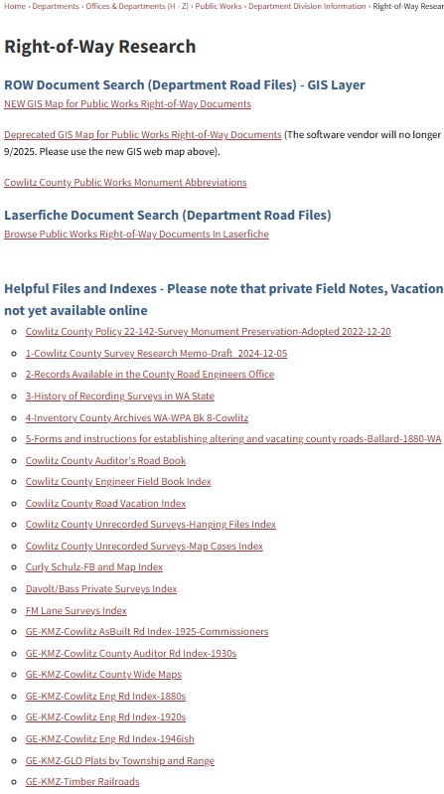

GIS Map for Public Works Right-of-Way Documents:
This tool will allow you to search for documents in the Public Works Laserfiche (LF) Road file by STR and Road Number. Just click on the green “road” in the area you are searching for, and all documents for the STR and Road Number that you select will show up. Note – the LF repository is still a work in progress: Not all documents included have correct metadata for STR and Road Number, so they may not pop up in the tool correctly. Some of the documents in LF are also black and white scans of color documents that are unreadable as B&W. I recommend using the “Browse… Laserfiche” link if you can’t find something that you think should be there (a waiver, establishment, etc.). It gets better and better as we go, but call if you run into issues.

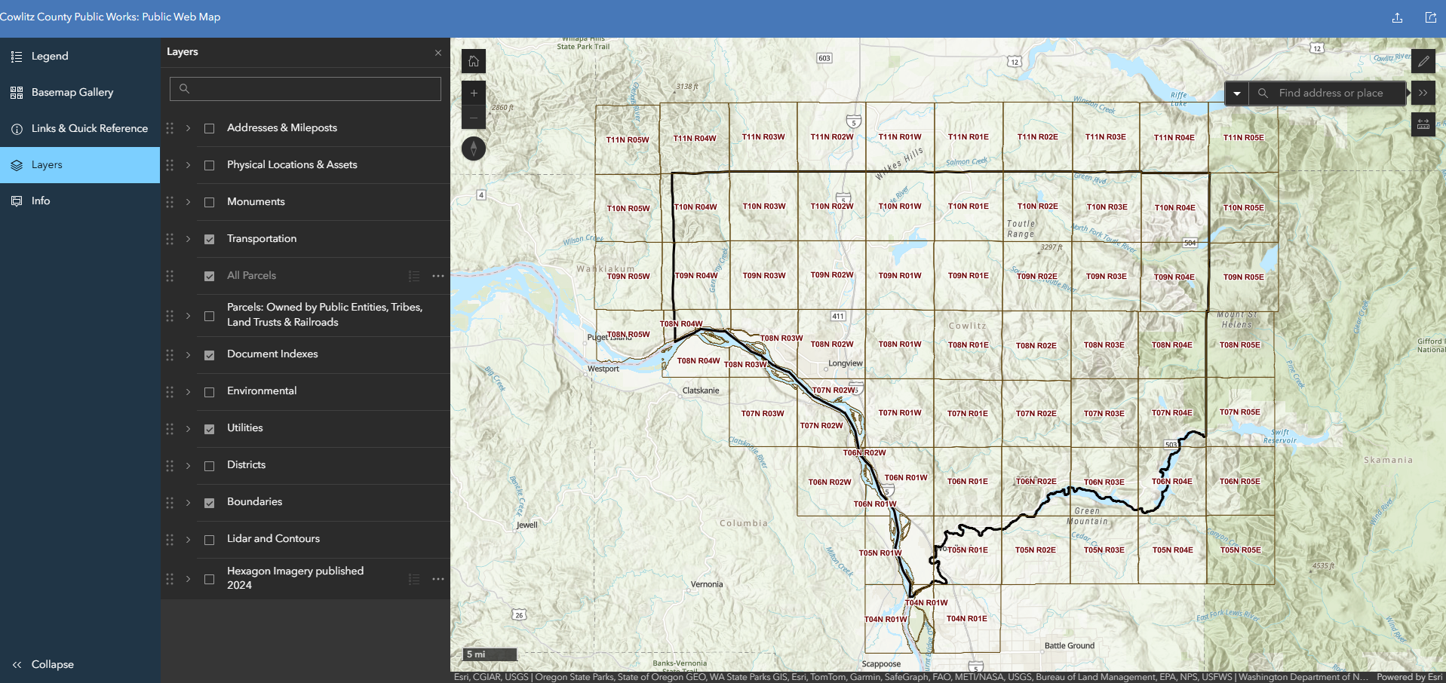

Here is the link:
https://cowlitz.maps.arcgis.com/apps/instant/sidebar/index.html?appid=09ec084f21a9406593d258d7ae4c0120

It can also be found on the ROW Research Page: http://www.co.cowlitz.wa.us/2446/Right-of-Way-Research

The main feature of the website is that you can search or navigate to your location and click on the green roadway. It will then search the County’s Laserfiche system for any documents in our Right of Way files and Right of Way maps that match both the Section Township and Range (STR) and Road Number of the section of road that you clicked on. You should see something similar to this:
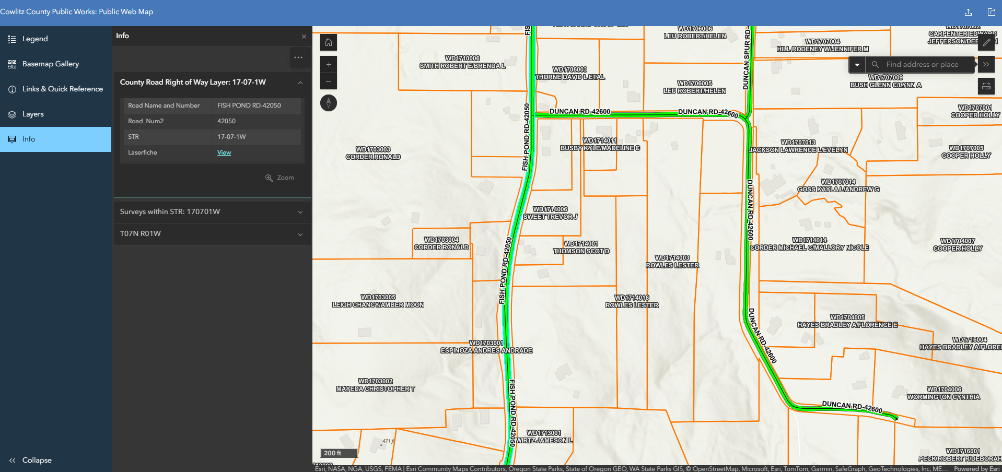

When you click “View” next to where it says “Laserfiche”, it takes you to the documents for viewing and downloading:
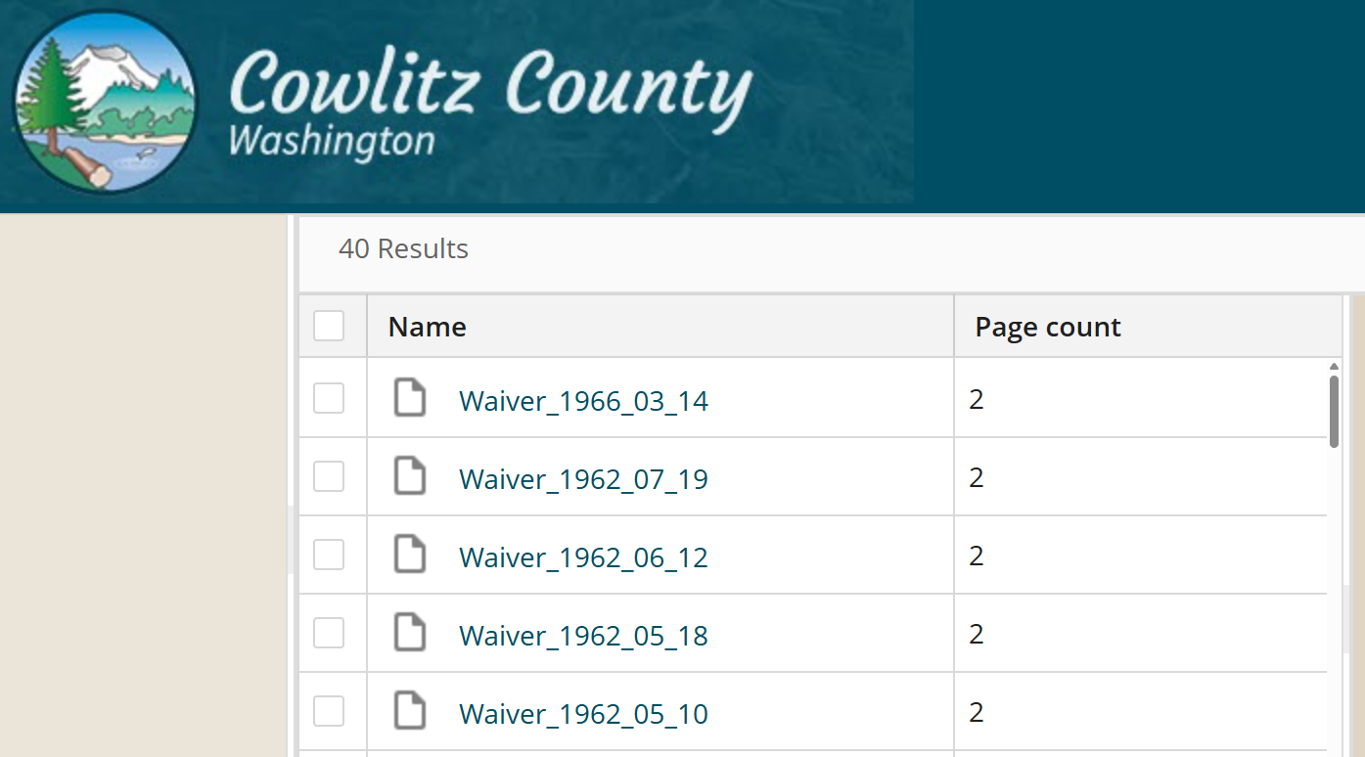

Some caveats/notes apply:

- Not all documents are available through the GIS Layer at this time. We are still in the process of adding and verifying metadata (STR and Road Number) for thousands of ROW documents. We are several years into this process though, so it’s getting pretty good at this point, and gets better all the time. If you don’t find something through the GIS link that you think should be there, try the direct laserfiche link (also on our ROW Research Page) and look in the digital Road File itself: http://apps.co.cowlitz.wa.us/WebLinkPublicWorks/Browse.aspx?startid=8548652 If you still don’t find the document(s) you are looking for, call us.

- Only our ROW maps, ROW files, Aerials, and PW Field Books are available online at this time. The majority of our unrecorded and recorded in the County Road Engineer’s Office surveys and field notes are not. We’ll add that as we go. If you don’t know what I mean by “Recorded in the County Road Engineer’s Office”, there is information on this past (1855-1963) law on the ROW Research Page: https://www.co.cowlitz.wa.us/DocumentCenter/View/19910/3-History-of-Recording-Surveys-in-WA-State

- GIS staff have been adding as many useful links and datasets to the GIS as they can. Eventually, we would like to have Assessor’s Tract Books, DNR Webextender, and other research information from other County departments and other agencies (that is complimentary with ROW research) available here by clicking in the map. A full list of currently available layers is below. Many of these layers will be turned off in the default view when you first launch the map. Click the check boxes to turn them on.

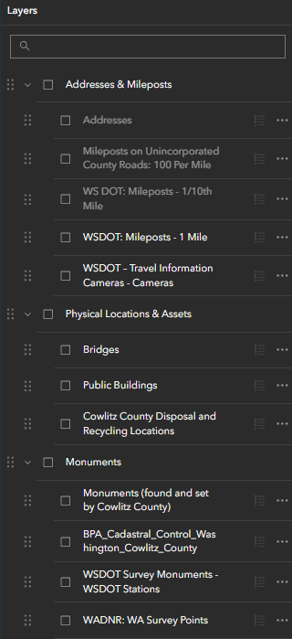
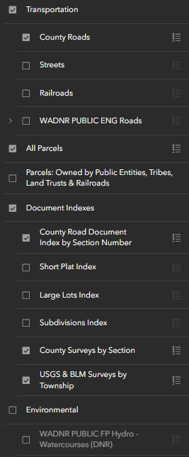
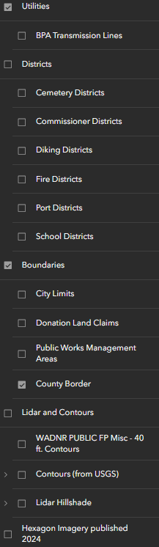

Laserfiche Database (Road Files):
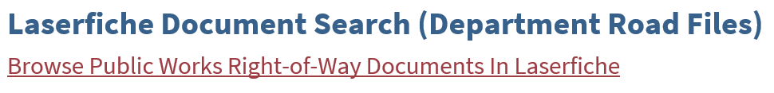
This tool allows you to browse through the Maps, PW Field Notes, and Right of Way section of the Public Works electronic database. You can also search by one of the selections in the list (STR, Road Name, Road Number), which will search the meta data for these things – same caveats apply as above.
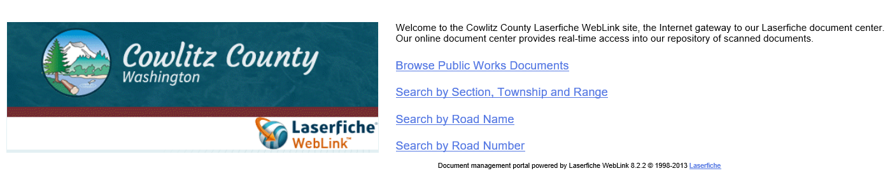
Selecting “Browse Public Works Documents” will get you here:
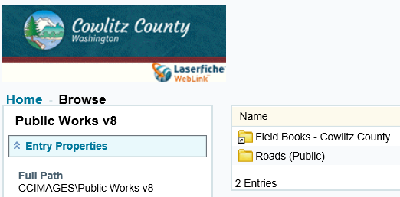
Selecting the “Field Books – Cowlitz County” folder will take you to the field books, by year and book number.
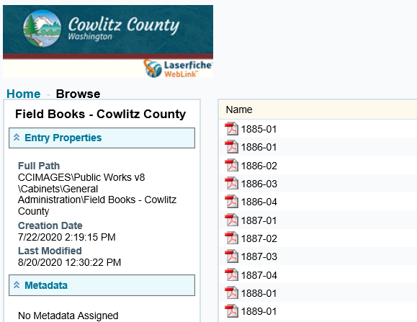

Selecting the “Roads (public)” folder will get you to a list of facilities and roads by name: 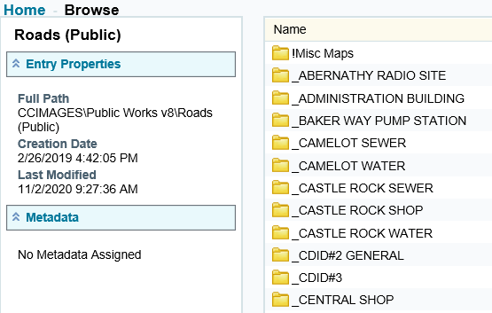 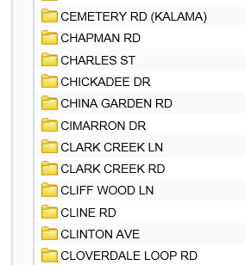

Research Indexes and Helpful Documents on the PW Website:
There are several indexes, useful documents, and Google Earth map overlays on the main Public Works Research Page that will help you in your research: http://www.co.cowlitz.wa.us/2446/Right-of-Way-Research
These are:

This is the Cowlitz County Public Works Monument Preservation policy that is required of every WA County in order to fulfill its CRAB reporting and policy obligations (in order to secure CRAB funding).

This document. Contains much of what we’ve been able to discover of the available records in Cowlitz County.

A .pdf of a PowerPoint for a presentation on what sorts of documents are available in the County Road Engineer’s Office. Contains many pictures and examples of documents.

A .pdf of a PowerPoint presentation regarding the laws regarding recording surveys in the County Surveyor/Engineer/Road Engineers’ Office.

A .pdf of the 1942 inventory of the Cowlitz County Records. Includes most/all departments, including the County Road Engineer’s Office, and a brief history thereof.

A .pdf of a book by a prominent attorney from Seattle (Irving Ballard) regarding setting up roadways in 1880. It was intended for County Commissioners and the like, so includes language that Ballard recommended be used in the documents for roadways, and is based on the laws and court cases of the time. Gives a good overview of the documents that one should be looking for in pre-statehood roads.

A .pdf of the Auditor’s Road Book, which used to sit in the Auditor’s Vault. This book contains Road Establishments, Surveyor’s Reports, and Commissioner’s Journal references to these documents for roads prior to about 1943. See page 25 herein.

An Excel spreadsheet of the Cowlitz County Road Engineer’s Field Book Index of field books from 1885 to present. See pages 8-12 herein for more information.
An Excel spreadsheet of Cowlitz County Vacations. See page 20 herein.
An Excel spreadsheet of an index of our “Hanging Files” which are one set of our County Road Engineer’s filed/recorded surveys. See page 13 herein.

An Excel spreadsheet of an index of our “Map Cases” which are one set of our County Road Engineer’s filed/recorded surveys. See page 14 herein.


An Excel spreadsheet of an index of our AE (Curly) Schulz (private local surveyor) maps and field books. See page 34 herein.


An Excel spreadsheet of an index of our Claud Davolt private maps, files, and field books. Claud was also County Surveyor/Engineer/Road Engineer. Russ Bass had these records for awhile and it appears that added a few things to them. See pages 15 and 31 herein.


An Excel spreadsheet of an index of our FM Lane private field books. Lane was also County Surveyor. See pages 15 and 33 herein.

A Google Earth .kmz file of the 1925 Cowlitz County Commissioner’s As-built mapping of County Roads. Appears to have been surveyed in to standards of the day. See also the Engineer’s Field Notes. Only includes the north half of the County for some reason. Useful for determining which older roads were actually built and used as of 1925, and the names thereof. See page 17 herein.

A Google Earth .kmz file of the 1930s era Cowlitz County Auditor’s index mapping of County Roads. More of a crayon sketch than an engineered map. Useful for determining the names used at the time, and for finding information about them in the Auditor’s Road Book, previously mentioned. See page 36 herein.

A Google Earth .kmz file of selected Cowlitz County historic road maps. Most of which were created by the County Surveyor/Engineer/Road Engineer. Useful for determining the names used at the time. The 1912 Schuele brothers map (showing ownership at the time is also herein). See page 17 herein. Not all maps we have are in the .kmz.

A Google Earth .kmz file of the 1880s Cowlitz County Auditor’s mapping of County Roads. Accuracy of locations fairly accurate, to surveying standards of the day. Useful for determining the location/length of older roads and the names used at the time. Also contains references to the Auditor’s Road Book(s) (different books than the 1930s one – see page 19). See page 17 herein.

A Google Earth .kmz file of the 1920s Cowlitz County Surveyor/Engineer’s mapping of County Roads. Accuracy of locations fairly accurate, to surveying standards of the day. Useful for determining the location/length of older roads and the names used at the time. See page 17 herein.


A Google Earth .kmz file of the 1940s Cowlitz County Surveyor/Engineer’s mapping of County Roads. Accuracy of locations fairly accurate, to surveying standards of the day. Useful for determining the location/length of older roads and the names used at the time. See page 17 herein.

A Google Earth .kmz file of the GLO maps/plats that have been useful to us to have in GE for County Projects. Does not include all of them in Cowlitz County.


A Google Earth .kmz file of the Timber RR maps that we have been able to find. Only includes two at the moment: Mosquito Creek and Mountain Timber Co.

GE Note: The default for the images in these .kmzs is set to be off. Having too many on at once bogs things down. Just turn on the individual image(s) that you need.

cc: File

