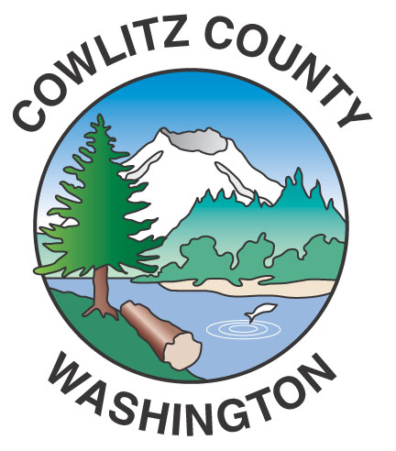
Cowlitz County Office of Administrative Services
207 N 4th Avenue, Room 308
Kelso, WA 98626

To ensure documents and communications reach you in a timely and accurate manner, please update your contact information and submit your budget and levy materials.

CONTACT INFORMATION
District Name:
Street Address:
City, State, Zip Code:
Contact Name: (for Budget & Levy)
Title
Telephone:
Email Address:
Date:

Updating your information will ensure we get documents to you in a timely manner.

You can email or mail this contact update form to:

Cowlitz County, Office of Administrative Services
Attn: Taunya Richardson
County Administration Building
207 Fourth Avenue North, Rm 308
Kelso, WA 98626
360-577-3065 ext. 6987
Email: richardsont@cowlitzwa.gov

Thank you!

