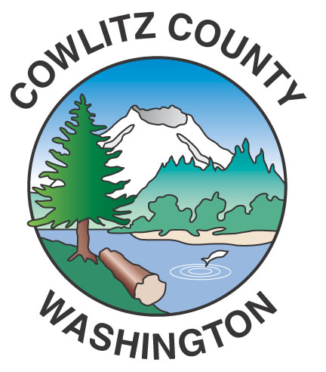

County Administration Building
207 Fourth Avenue North
Kelso, WA 98626
TEL (360) 577-3020
FAX (360) 423-9987
www.co.cowlitz.wa.us

Cowlitz County

News Release

Contact

Commissioner’s Office

Phone: (360) 577-3020

August 31, 2021
Kelso, WA

Cowlitz County Board of Commissioners accepting
Applications for the office of County Commissioner of District No. 3

Cowlitz County Commissioner District No. 3 position will be vacated by Commissioner Joe Gardner, effective September 3, 2021 at 5:00 p.m.
The Board of Commissioners request an application from interested registered voters, meeting the qualifications for the office of county commissioner and residing in District 3, no later than the close of business at the Commissioners’ Office Friday, September 10, 2021. Such applications may be e-mailed to the Clerk of the Board, Tiffany Ostreim at: ostreimt@co.cowlitz.wa.us
Such applications shall include a letter of qualification, a resume, acknowledgement of compliance with the PDC F1 requirements of financial disclosure, and a signed statement as is required from electoral candidates for this office:
I declare the information contained in my application is true, that I am registered voter residing at the address listed in my application, and that at this time I am legally qualified to assume this office. Further, I swear or affirm that I will support the Constitution and laws of the United States, and the Constitution and laws of the State of Washington.
Note that applications become part of the public record, and the final step of selection will involve interviews open to the public.

There is a specific Candidate Review Committee [consisting of Three Independent County Elected Officials, a Republican County Elected Official and a Democratic County Elected Official] which has been formed to solicit specific recommendations on each candidate expressed as a ranked order list of preference. From the list of applicants, the two sitting commissioners will select three candidates to advance for a final decision to select only one candidate. Recommendations from the committee are due to the Board of County Commissioners no later than September 17, 2021.

The commissioners have to arrive at a decision within sixty days, otherwise the Clerk of the Board will send the names of three nominees along with their submitted applications to the Governor of the State of Washington for final determination.

