County Administration Building
207 Fourth Avenue North
Kelso, WA 98626
TEL (360) 577-3020
FAX (360) 423-9987
www.co.cowlitz.wa.us

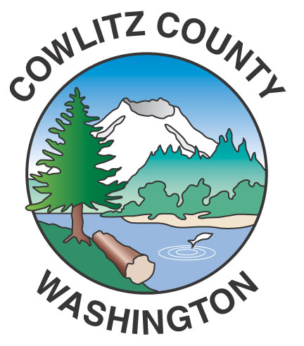

Cowlitz County

Contact

Human Resources

Phone: (360) 577-3065 x2792

March 28, 2019

Kelso, WA

News Release
Salary Commission Meeting
April 10, 2019 at 5:30 p.m.
1st Floor of the Administration Building

The Cowlitz County Citizens’ Commission on Salaries for County Commissioners will meet
Wednesday, April 10, 2019, at 5:30 p.m. on the 1st floor of the Administration Building in Conference Room B, located at 207 Fourth Avenue North, Kelso, WA 98626.

-End-

