County Administration Building
207 Fourth Avenue North
Kelso, WA 98626
TEL (360) 577-3020
FAX (360) 423-9987
www.co.cowlitz.wa.us

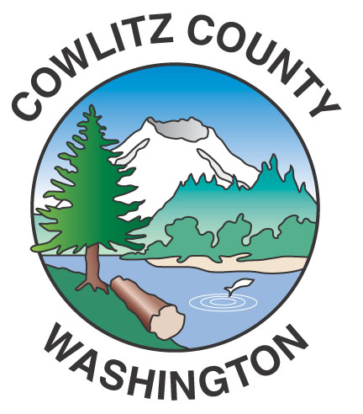

Cowlitz County

Contact

Commissioners Office

Phone: (360) 577-3020

September 20, 2017

Kelso, WA

News Release

County Statement on Shoreline Hearing Board Decision for Kalama Methanol Manufacturing and Export Facility

The Board of Commissioners recognizes the importance of both economic development and protecting our environment. Cowlitz County needs the jobs generated by quality, environmentally responsible projects such as the Kalama Methanol Manufacturing and Export Facility at the Port of Kalama. Our staff worked closely with the Port of Kalama and Northwest Innovations Works, to complete a thorough and rigorous analysis of the environmental impacts of the proposed project. A project of this size requires the work and coordination of experts from many different disciplines. For the analysis of Greenhouse Gas (GHG) emissions there is no law or rule from which to define adequate environmental review; the guidance and input of the Department of Ecology is critical. County staff adhered to the only GHG guidance available, absent any other guidance or input to the contrary. We support the quality work completed by our staff, the Port of Kalama and the team of expert consultants who collaboratively completed this complex environmental review and we are disappointed in the decision made by the Shoreline Hearings Board.

Our County staff works to encourage and support economic development, including permitting water dependent industrial and commercial projects. Cowlitz County benefits from its placement on three major transportation corridors; the Columbia River, I-5, and mainline rail. It will continue to be the County’s goal to responsibly permit and develop projects that contribute to the economy of Cowlitz County while improving and preserving our quality of life and place.

The County remains committed to working collaboratively with our partners at the Port of Kalama to complete the permitting process and bring this important project to Cowlitz County.

