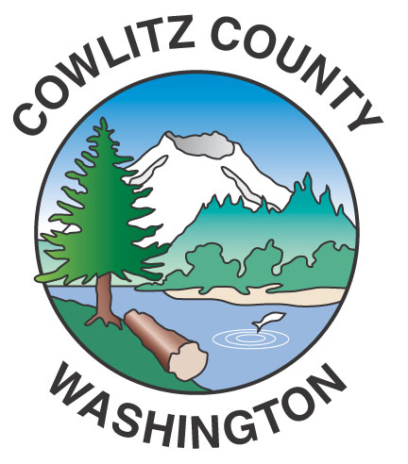

County Administration Building
207 Fourth Avenue North
Kelso, WA 98626
TEL (360) 577-3020
FAX (360) 423-9987
www.co.cowlitz.wa.us

Cowlitz County

Contact

Commissioner’s Office

Phone: (360) 577-3020

News Release

July 14, 2017
Kelso, WA

Special Joint meeting of the
Cowlitz County Board of Commissioners and the Cowlitz County Planning Commission
July 19, 2017 at 7:00 p.m.

The Cowlitz County Board of Commissioners will be attending a Special Joint Meeting on Wednesday, July 19, 2017 with the Cowlitz County Planning Commission at 7:00 p.m., Third Floor, County Administration Building, 207 N. Fourth Avenue, Kelso.

The Board of County Commissioners will conduct its annual meeting with the Planning Commission and consider the Planning Commission’s recommendation on the Comprehensive Plan Update.

