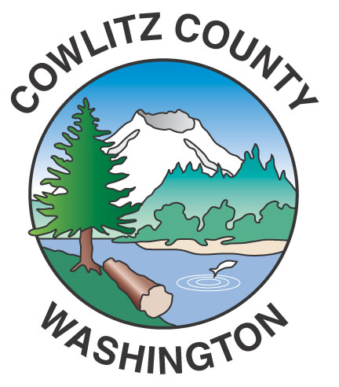

County Administration Building
207 Fourth Avenue North
Kelso, WA 98626
TEL (360) 577-3020
FAX (360) 423-9987
www.co.cowlitz.wa.us

Cowlitz County

Contact

Commissioner’s Office

Phone: (360) 577-3020

News Release

June 20, 2017
Kelso, WA

The Cowlitz County Board of Commissioners will not meet in regular session Tuesday, July 4, 2017

The Board of Commissioners’ regularly scheduled meeting of Tuesday, July 4, 2017 is canceled due to Independence Day.

The next regular meeting for the Board of Commissioners will be held on Tuesday, July 11, 2017 at the regular time of 9:00 a.m.

County Commissioner regular meetings are held every Tuesday at 9:00 a.m. in the Commissioners’ Hearing Room, Room 303, located on the third floor of the Cowlitz County Administration Building, 207 Fourth Avenue North, Kelso, Washington

~End~

