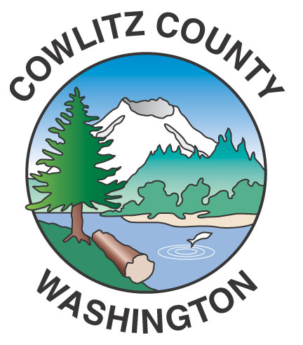

County Administration Building
207 Fourth Avenue North
Kelso, WA 98626
TEL (360) 577-3020
FAX (360) 423-9987
www.co.cowlitz.wa.us

Cowlitz County

Contact

Commissioners’ Office

Phone: (360) 577-3020

May 26, 2017

Kelso, WA
News Release

Final Board of County Commissioners Review on the Cowlitz County Comprehensive Plan
Scheduled for June 13, 2017 at 7:00 p.m.

Final review on the Cowlitz County Comprehensive Plan is scheduled for June 13, 2017 at 7:00 p.m. in the Commissioner’s Hearing Room.

It is with great pleasure the Board announces they will hold a final review of the Cowlitz County Comprehensive Plan on June 13, 2017 at 7:00 p.m. The final hearing night will wrap up five months of well-attended evening meetings in which the Board heard and considered public comments from the community. Public comments received during the round of hearings with the Board supplemented the existing record and were used to make further edits to the Draft Comp Plan. Following the final review, it is expected that the Board will send the Draft back to the Planning Commission for their recommendations prior to final adoption by the Board. A joint meeting with the Planning Commission will be held on July 19th.

